**AZURE**

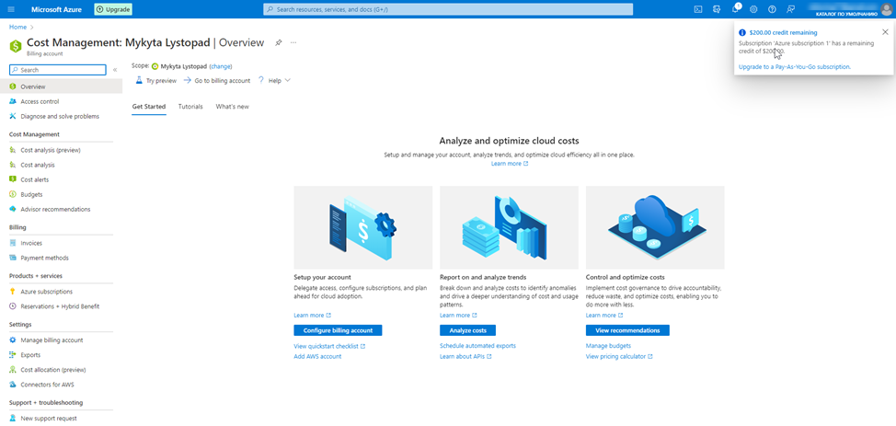

**First of all you need to switch subscription in default directory for apply free billing 200 dollars !!!!!!!!!!**

# **Prerequisites**

**Create azure subscription**

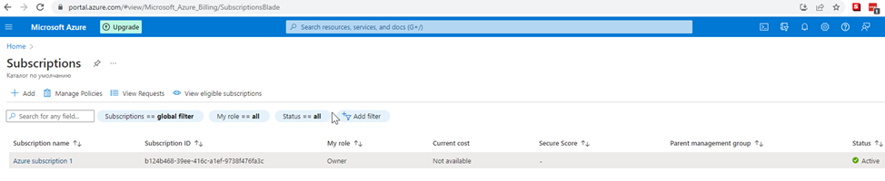

**Create azure devops organization**



**Installing Terraform and Azure Cli**

**1 Download to any directory**

**2 Add path in system env this folder**

**C:\Users\Nik>terraform version**

**Terraform v1.3.4**

**on windows_amd64**

**3 Download and install Azure CLI**

**C:\Users\Nik>az version**

**{**

**"azure-cli": "2.42.0",**

**"azure-cli-core": "2.42.0",**

**"azure-cli-telemetry": "1.0.8",**

**"extensions": {}**

**}**

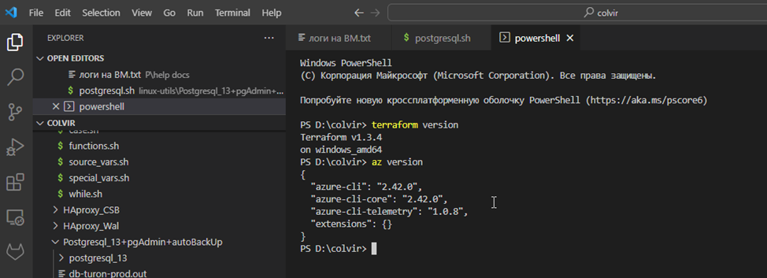

# **Homework**

## **Part 1 – Configure application**

1. Create a service connection in a Azure DevOps project to your subscription -<https://learn.microsoft.com/en-us/azure/devops/pipelines/library/service-endpoints?view=azure-devops&tabs=yaml>

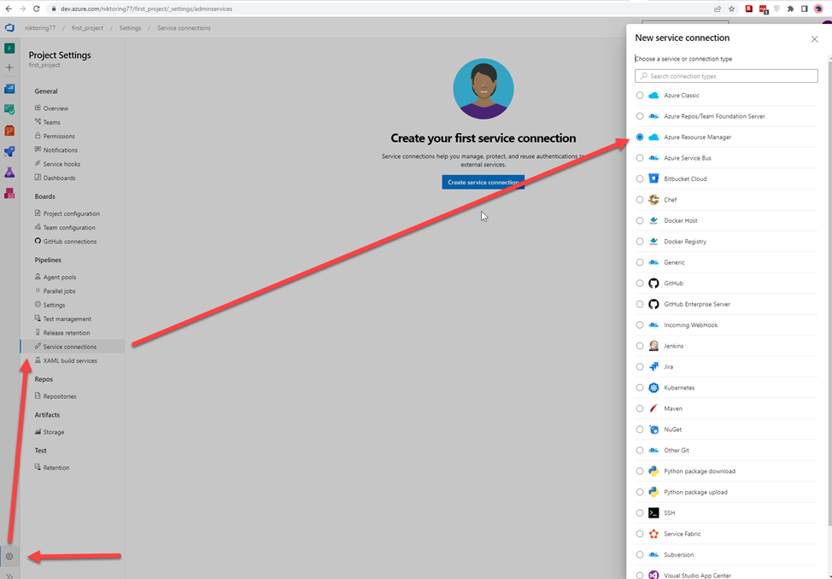

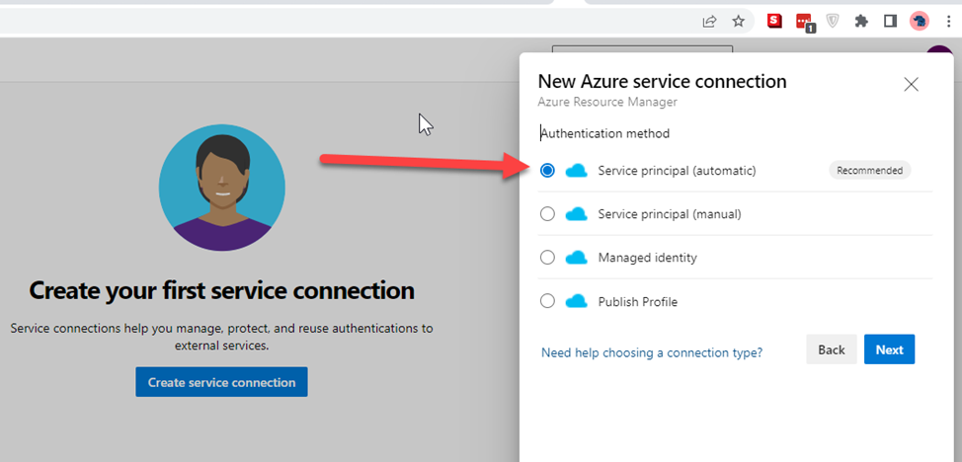

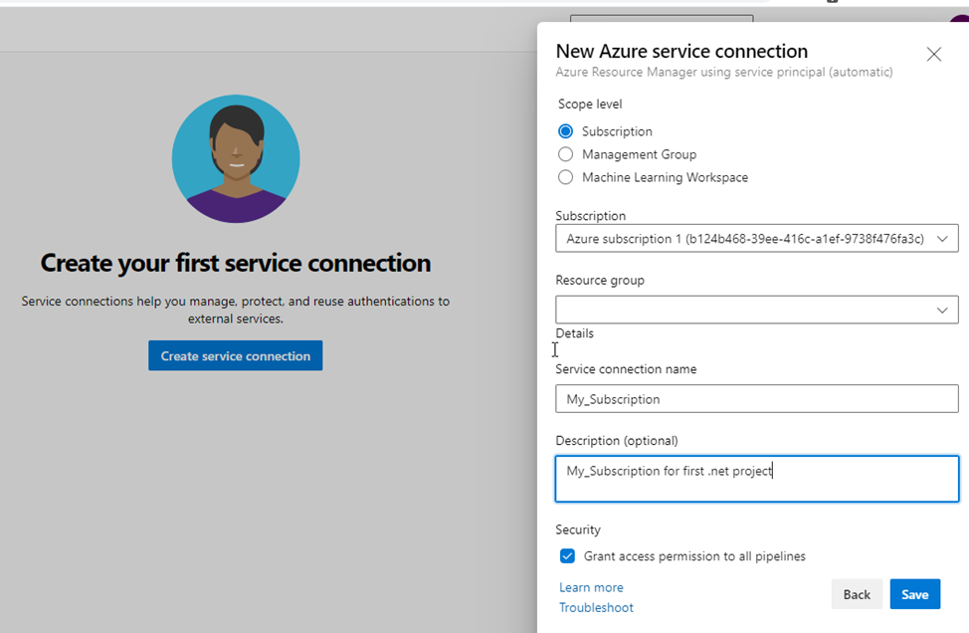

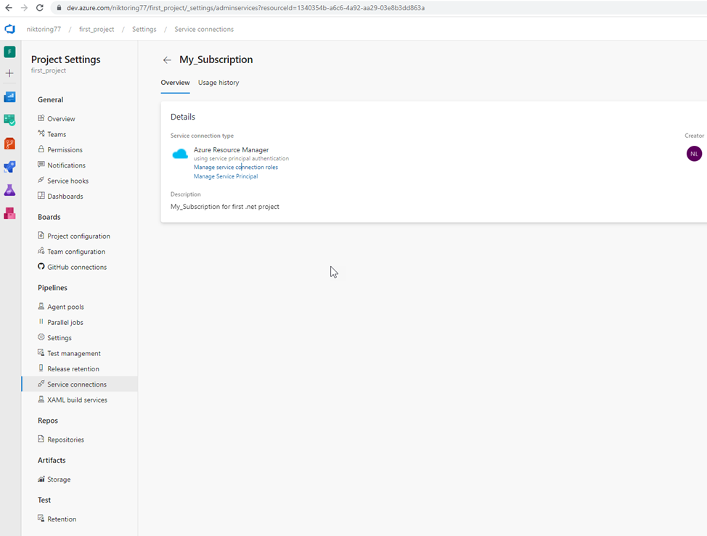

**4** **Create an Azure DevOps repo -** [**https://learn.microsoft.com/en-us/azure/devops/repos/git/create-new-repo?view=azure-devops**](https://learn.microsoft.com/en-us/azure/devops/repos/git/create-new-repo?view=azure-devops) **You can use import repository to import from existing source control version like github**

**Add to Azure repo my project**

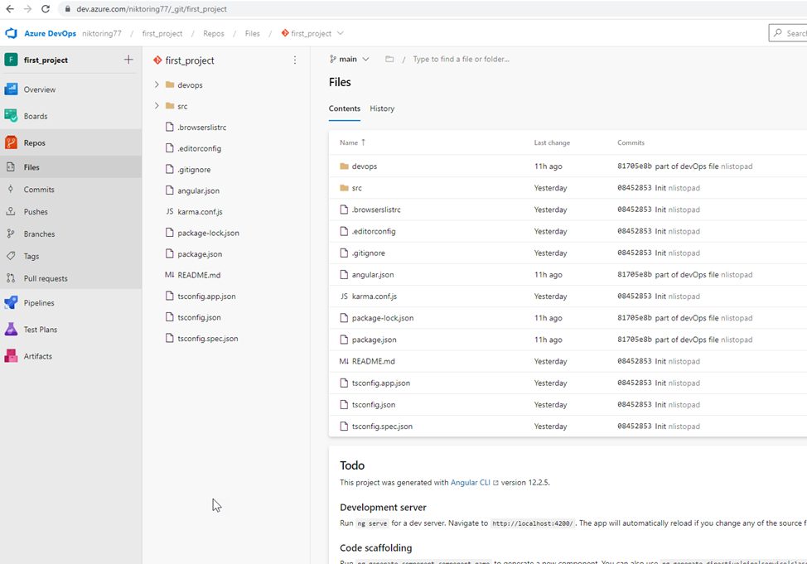

**2)** **Find a .net pet project for the experiments. I find my Angular project**

**Create pipeline**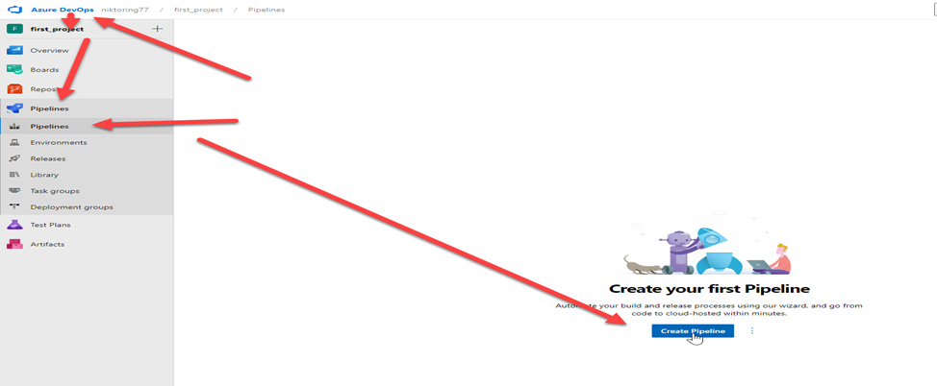

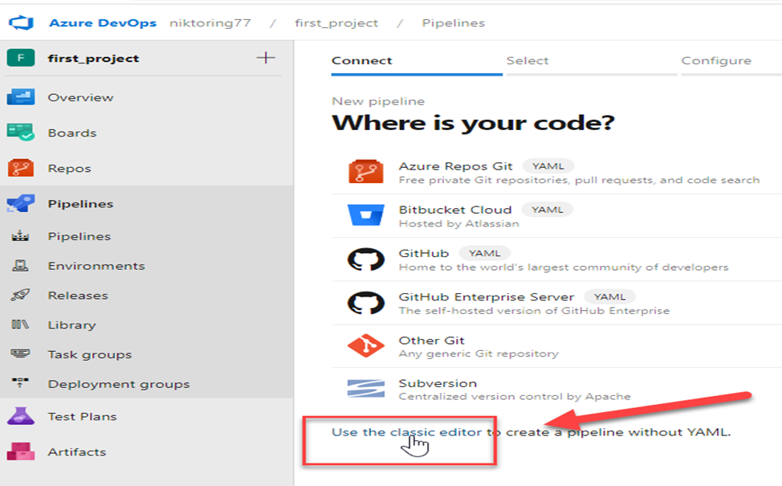 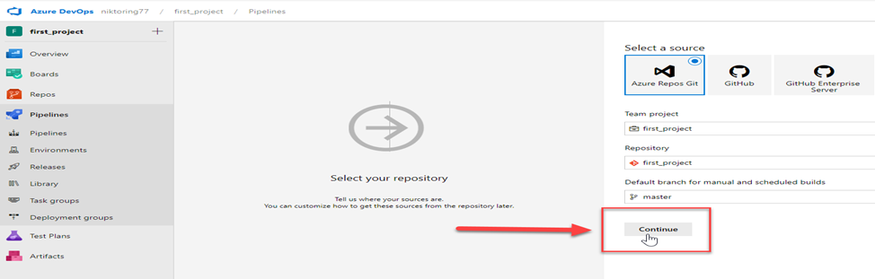

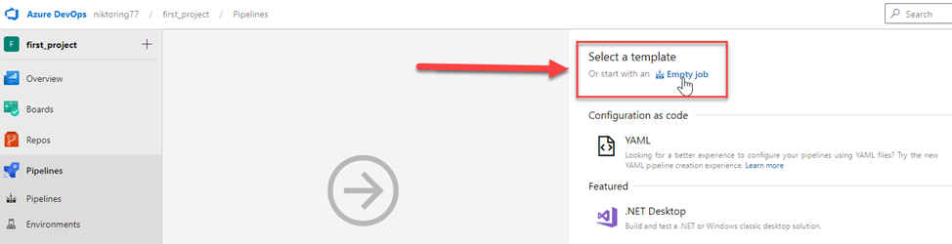

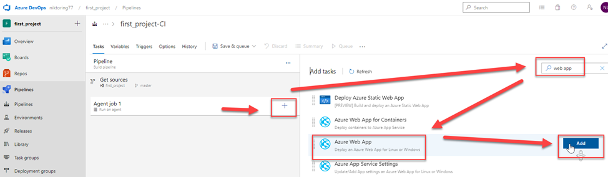

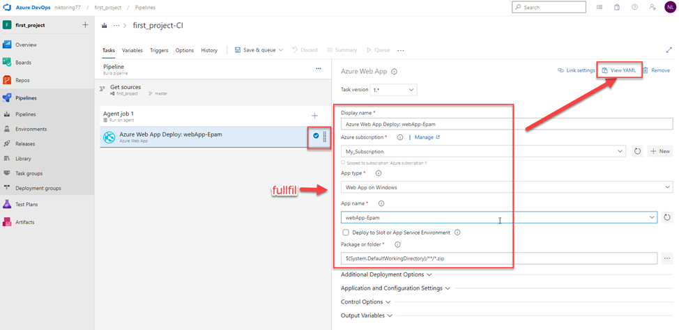

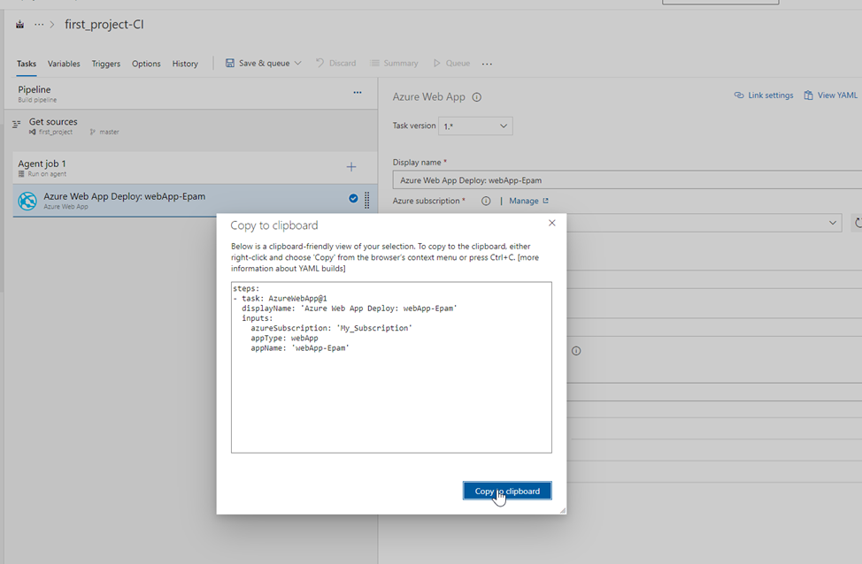

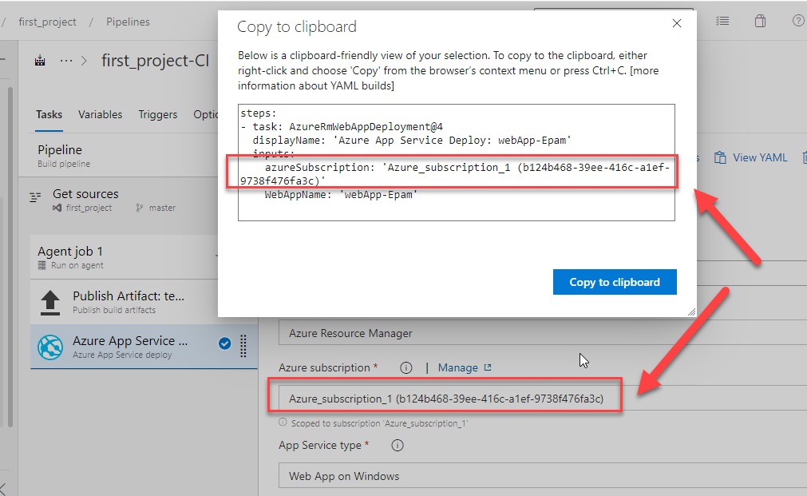

**CREATE or APPROVE your subscribe !!!!!!**

**Add part of code to project**

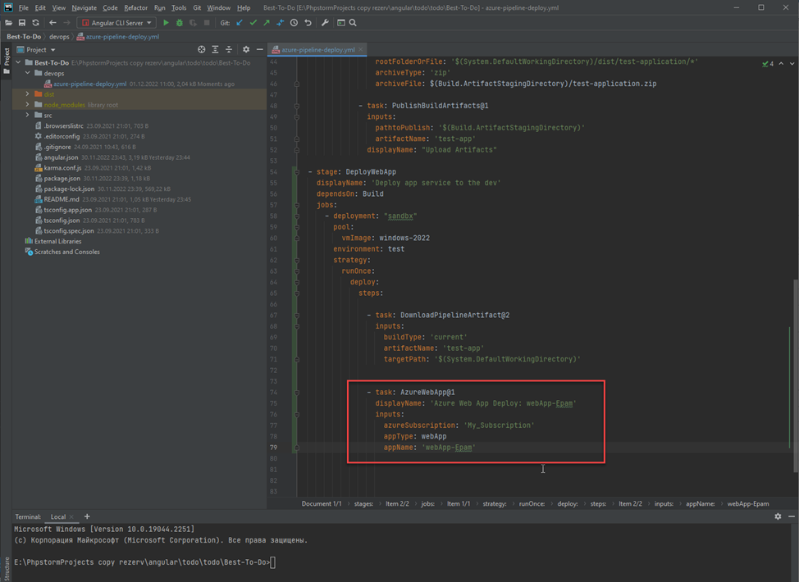

**+ We need to add some parameters**

**Read in manual**

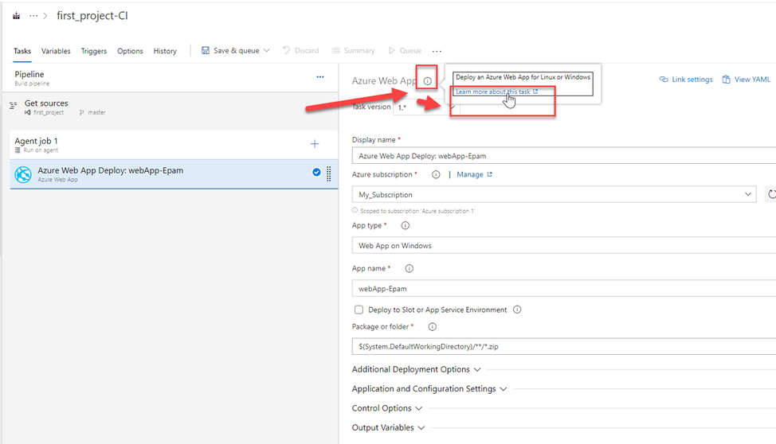

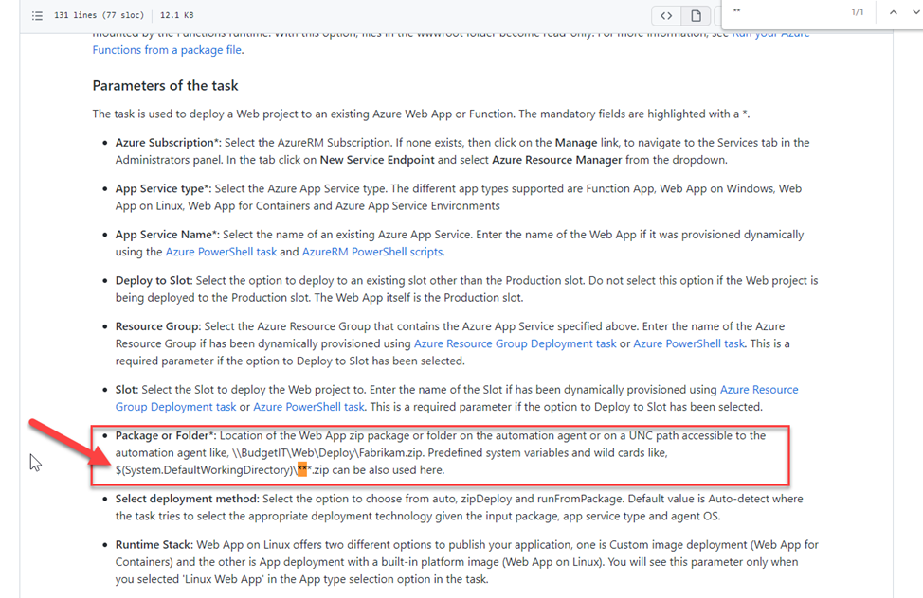

**We need to add:**

package: '$(System.DefaultWorkingDirectory)/**/*.zip'

resourceGroupName: test

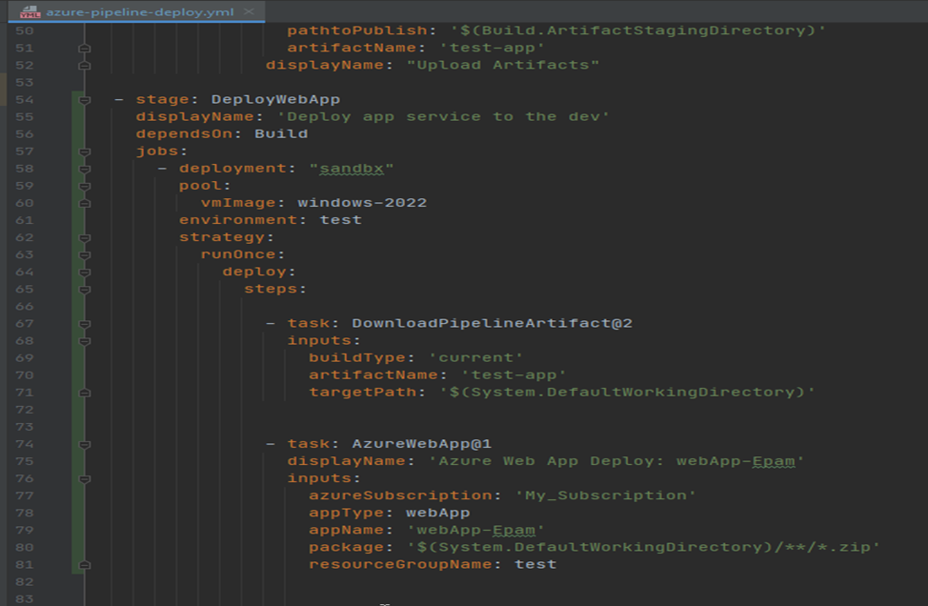

**Push changes to Azure repo**

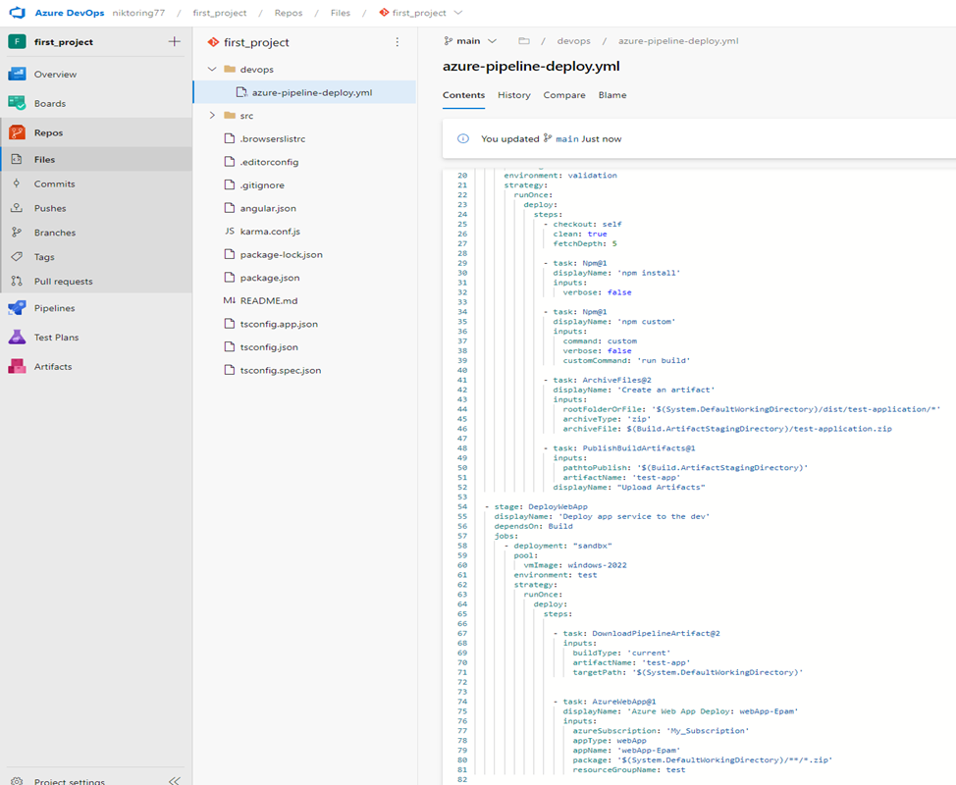

**Do pipeline**

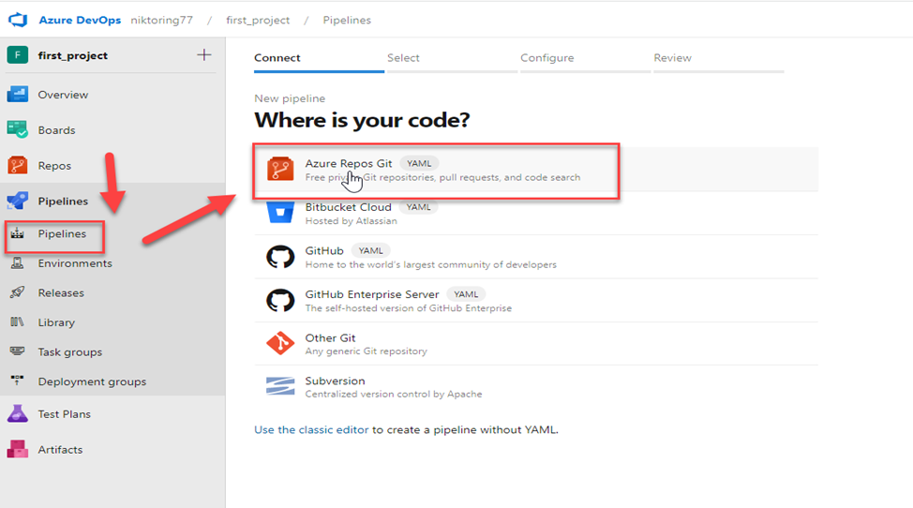

**Choose our app**

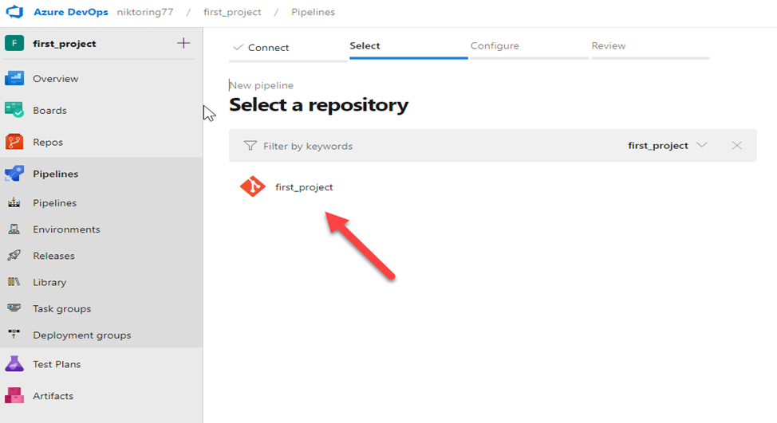

**I pushed to main branch. I need create merge request to DEFAULT branch. in my case it is Master**

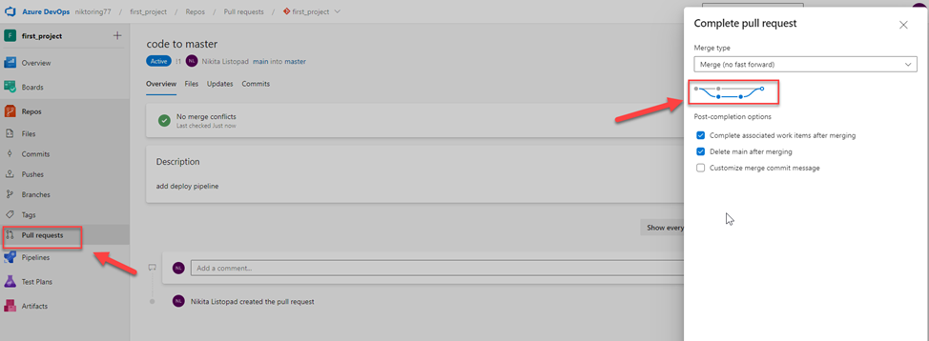

**Then**

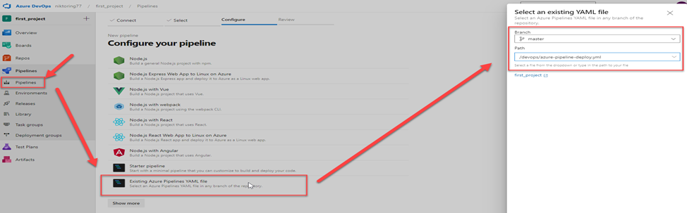

**Continue**

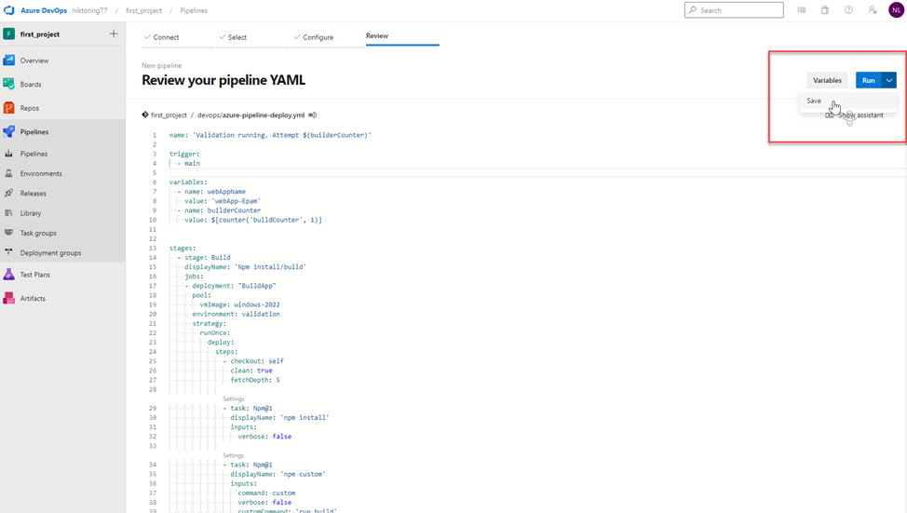

**We have useful options**

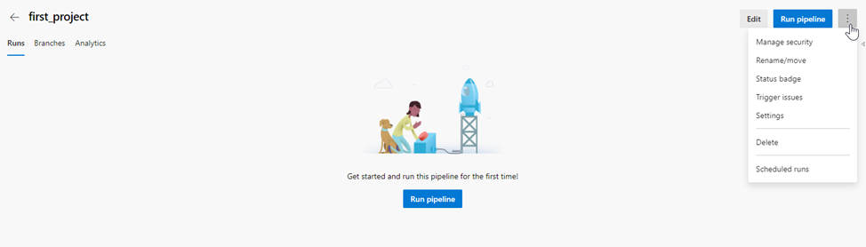

**Edit**

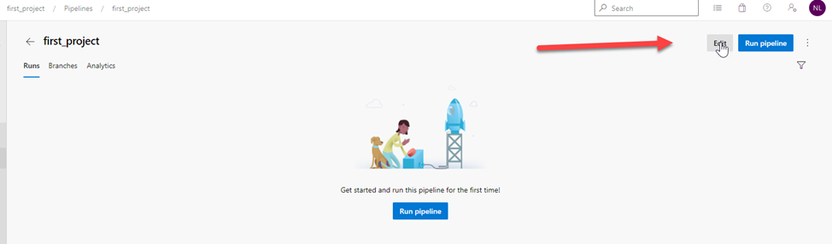

**Check valid our file .yml**

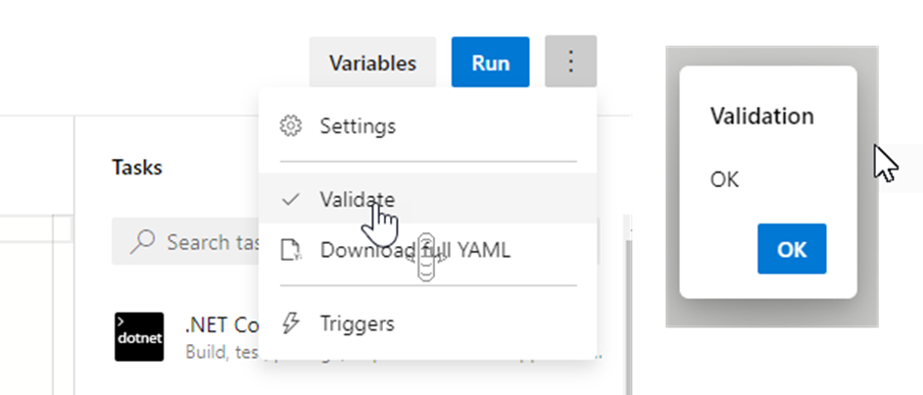

**Run pipeline**

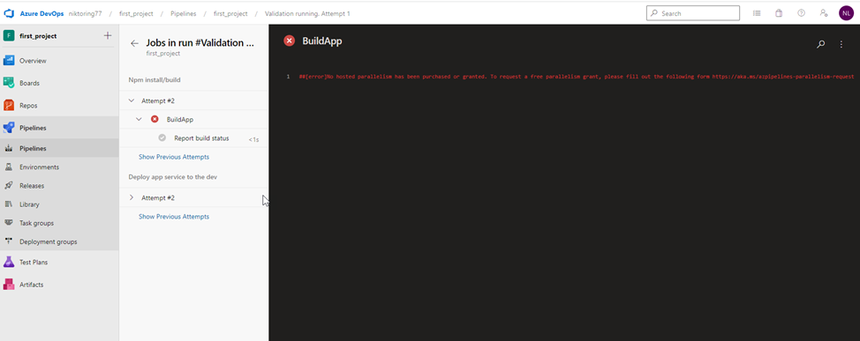

**Send request**

**https://forms.office.com/pages/responsepage.aspx?id=v4j5cvGGr0GRqy180BHbR63mUWPlq7NEsFZhkyH8jChUMlM3QzdDMFZOMkVBWU5BWFM3SDI2QlRBSC4u**

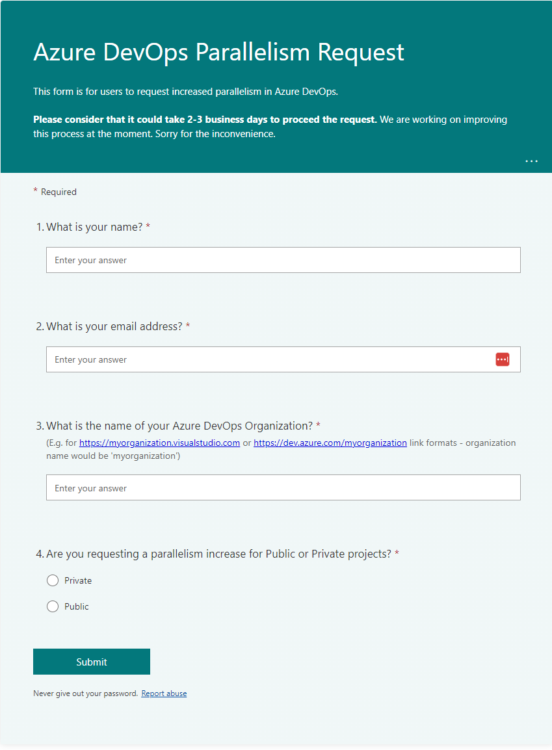

Approval

Where is code on VM in Web-App

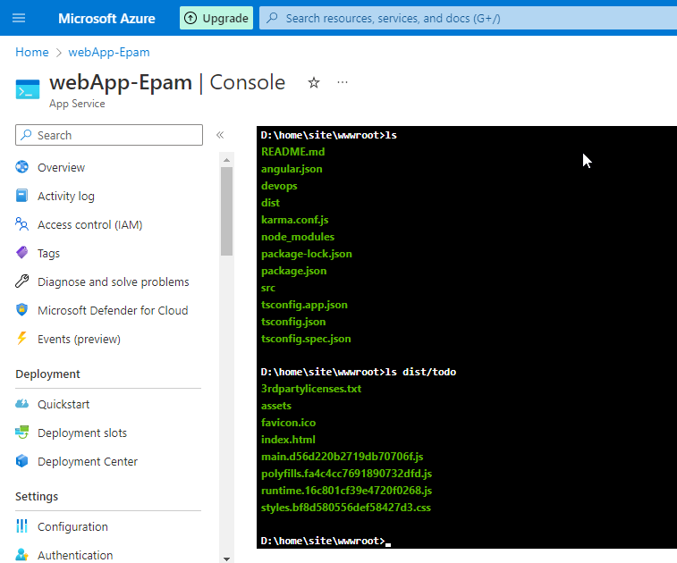

Successful pipeline after error bind with:

rootFolderOrFile: '$(System.DefaultWorkingDirectory)/dist/todo/*'

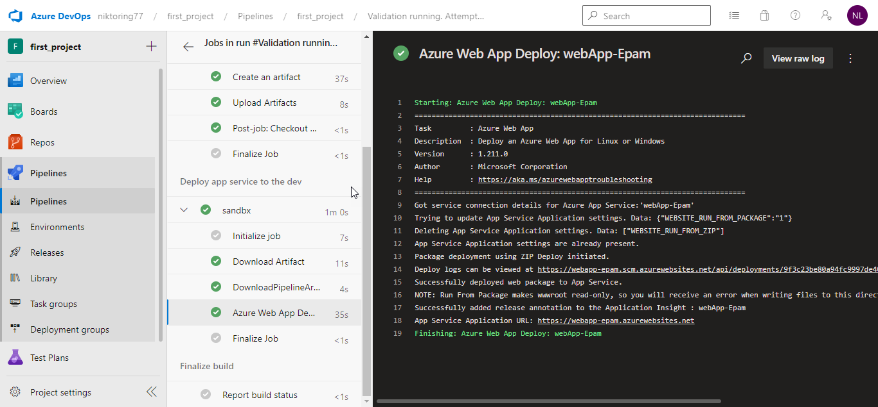

Show result

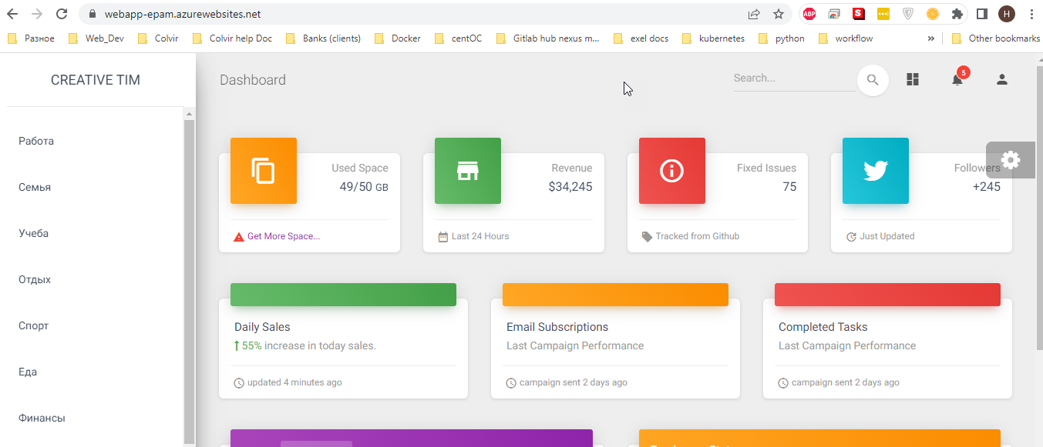

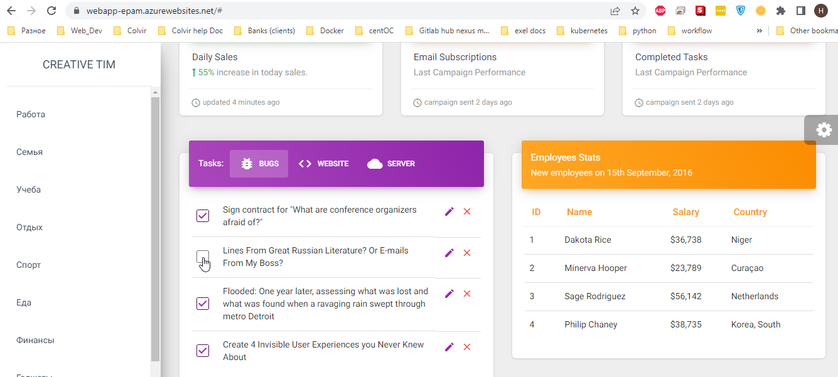

## **Part 2 – Configure a pipeline to deploy infrastructure**

Below is describing on how to do it via terraform. If you want to use terraform you need to create service connection in manual way. Otherwise you won’t be able to deploy your iac – Navigate to the last section

### **Terraform storage account**

1. **Create a separate resource group and deploy azure storage account -**<https://learn.microsoft.com/en-us/azure/storage/common/storage-account-create?tabs=azure-portal>

Create storage account for some resource group!!!! Example for epam_test

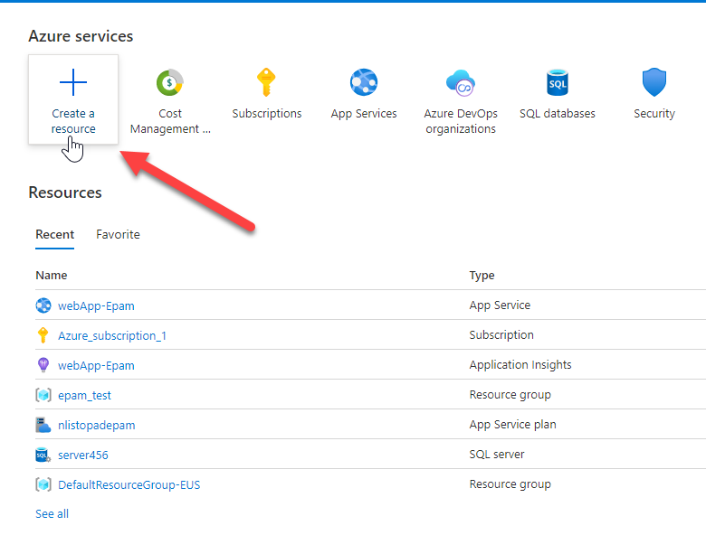

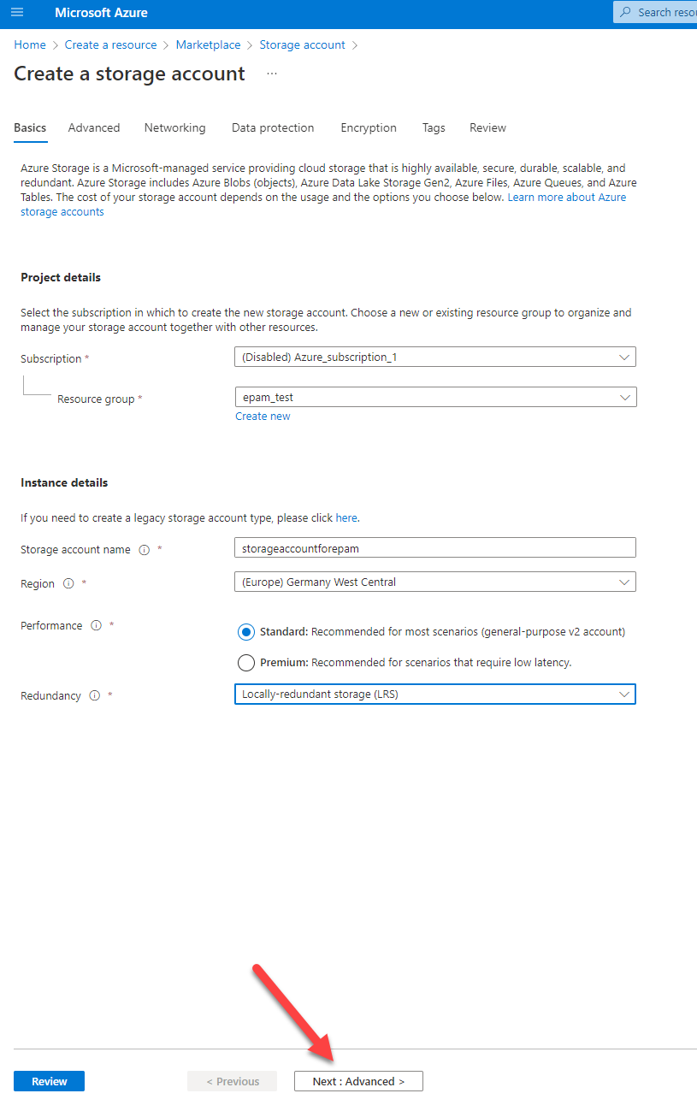

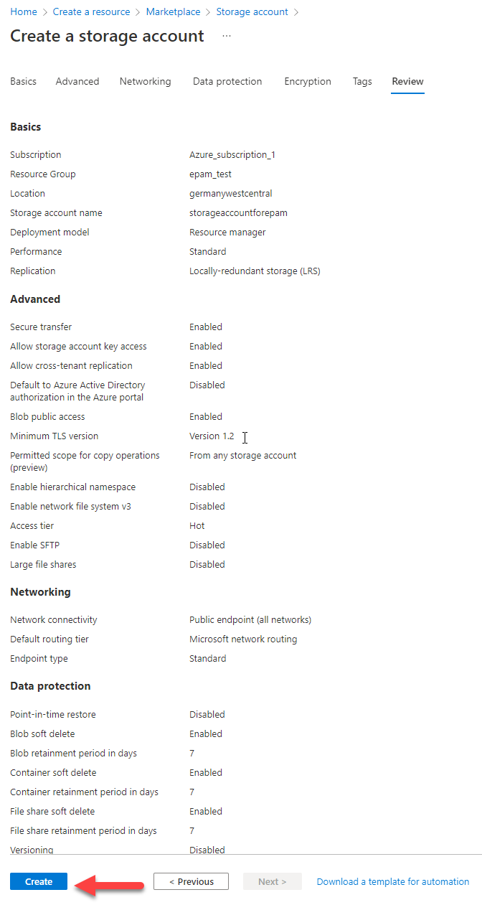

**2. Create a container with the name “tfstate” and remember the name. use portal settings**

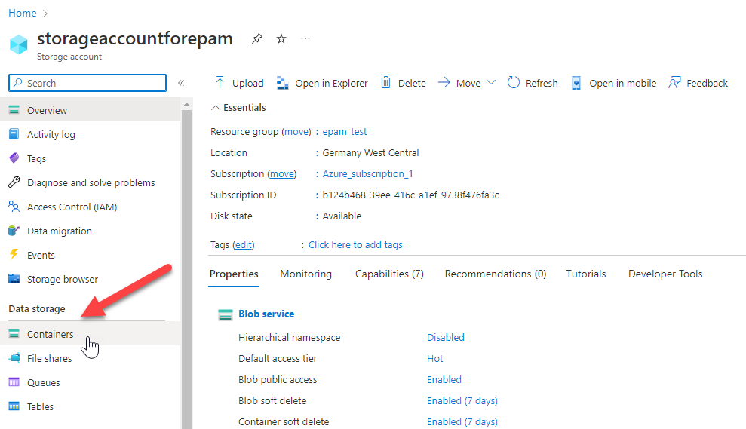

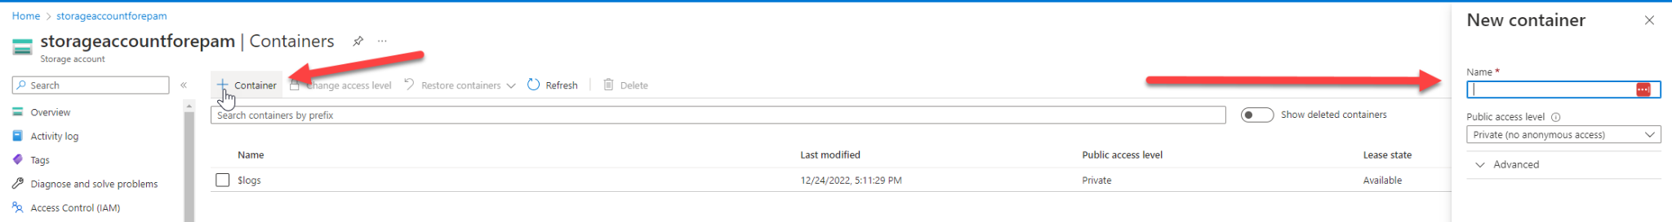

In this storage account you will be store your tf state file

### **Terraform preparation**

prepare vsCode

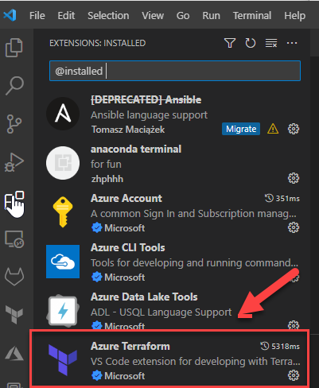

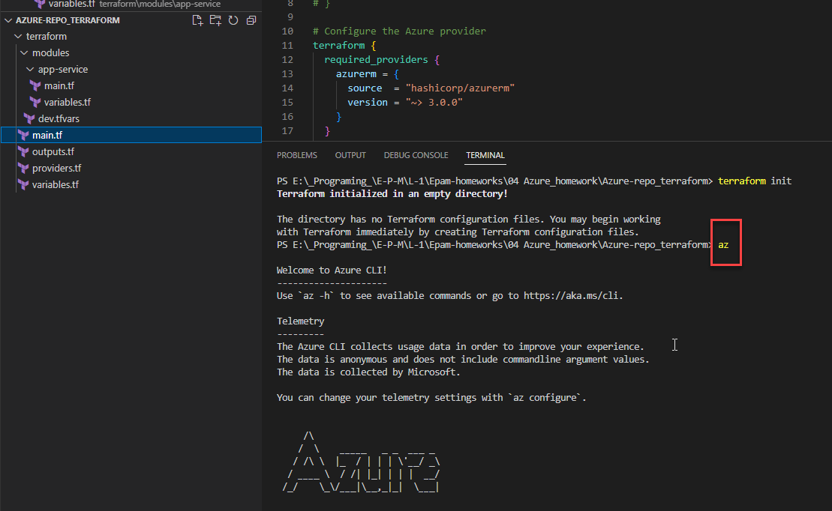

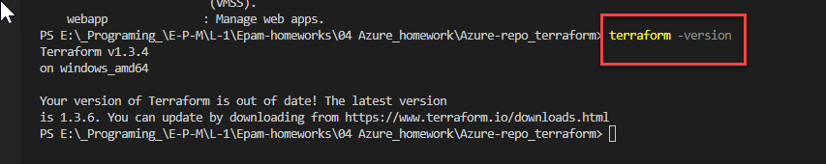

**1. Create another repo to store devops code**

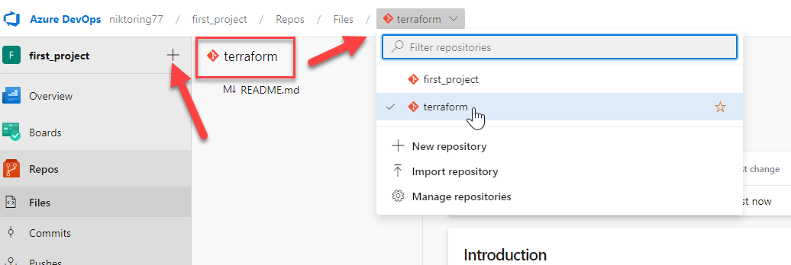

**2. Create a folder terraform**

on local vsCode

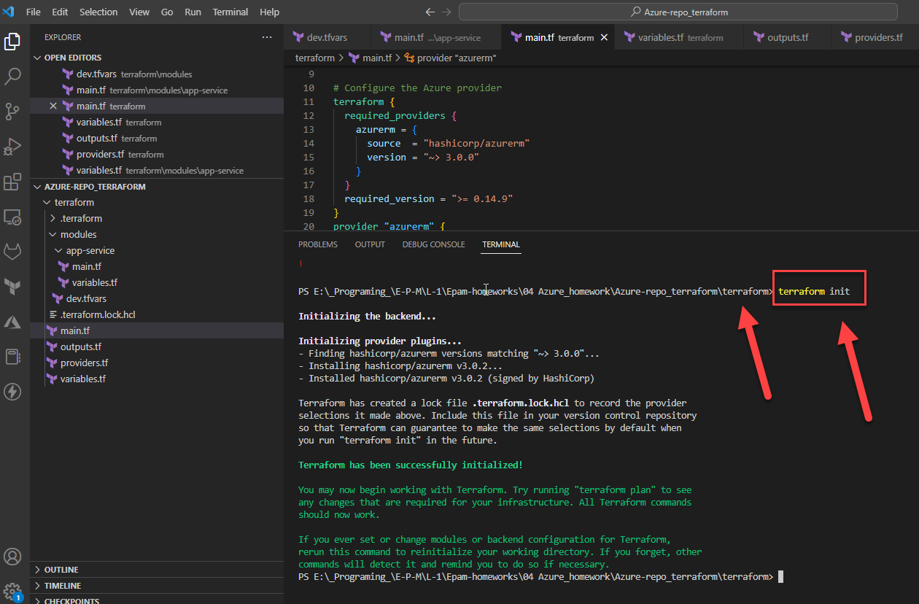

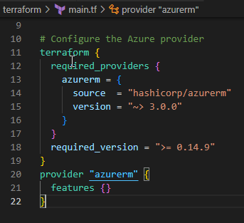

cd terraform

terraform init

**3. Add app service implementation -**<https://learn.microsoft.com/en-us/azure/app-service/provision-resource-terraform>

**az login** because without login I can’t apply and create resource and services!

connect to your existing Azure account

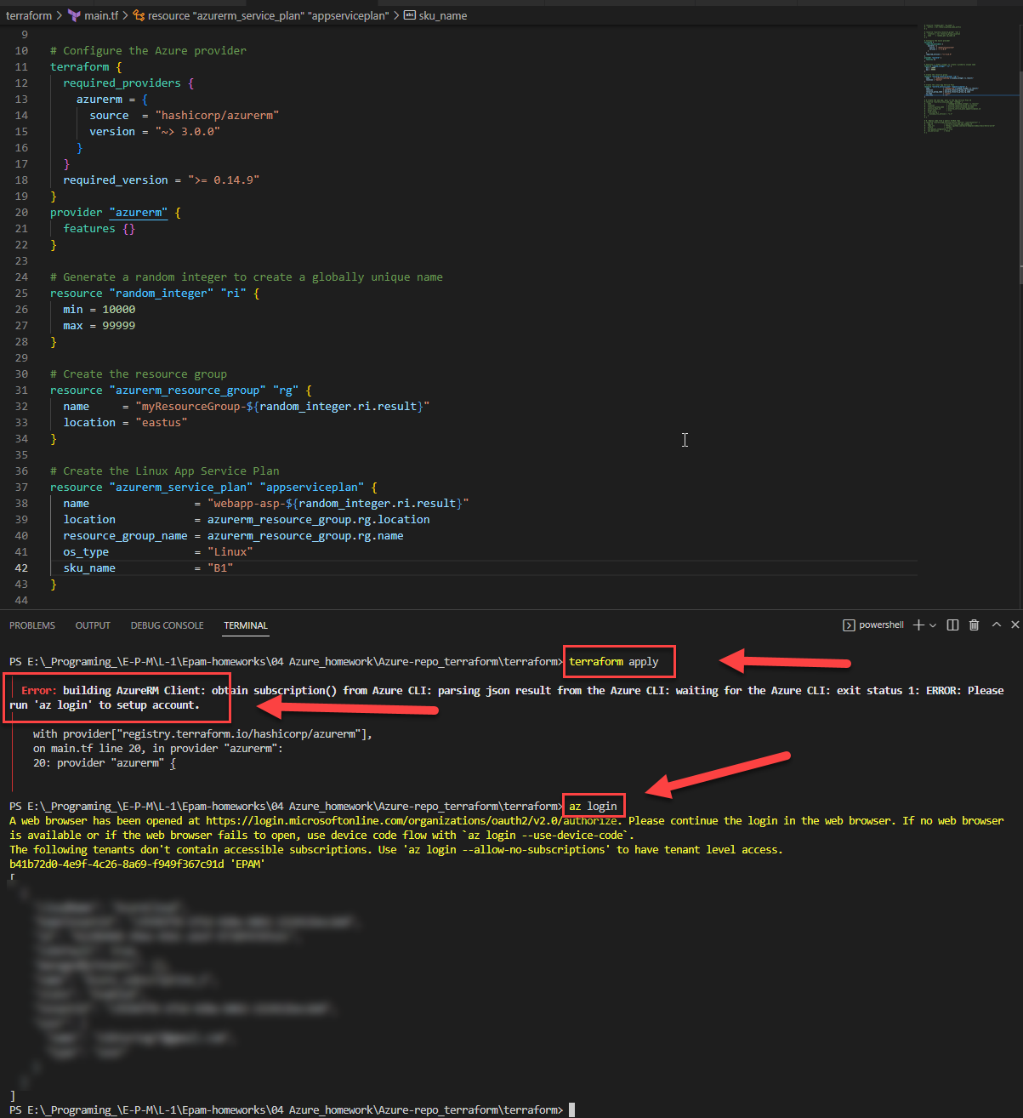

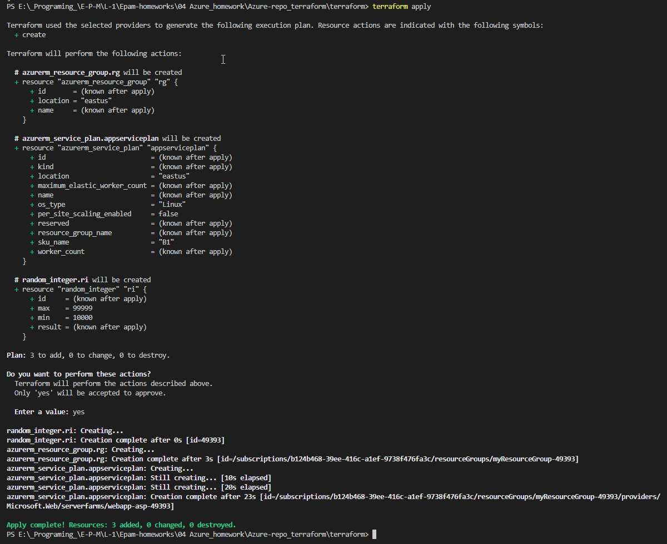

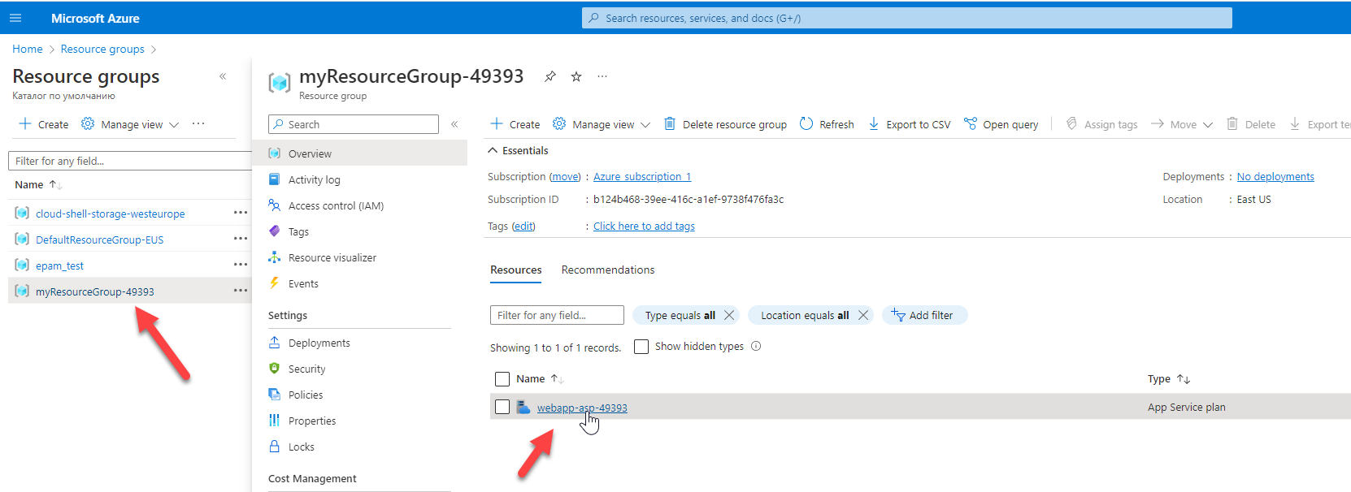

**4. Integrate application insights with app service**

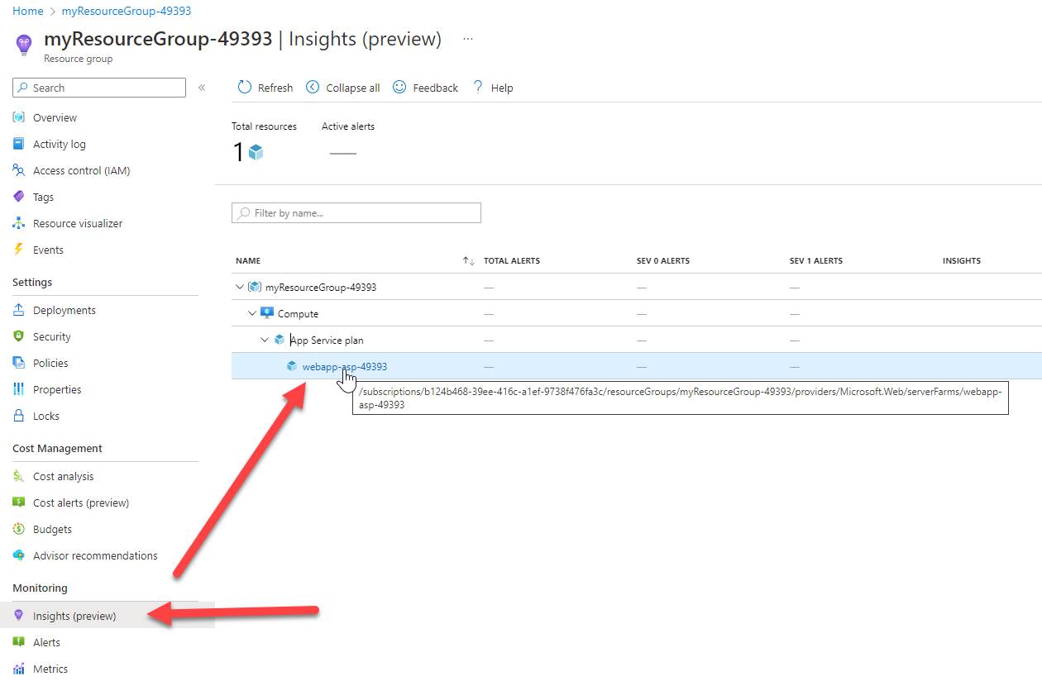

5. Updated backend “azurerm” according to the guide -<https://learn.microsoft.com/en-us/azure/developer/terraform/store-state-in-azure-storage?tabs=azure-cli>

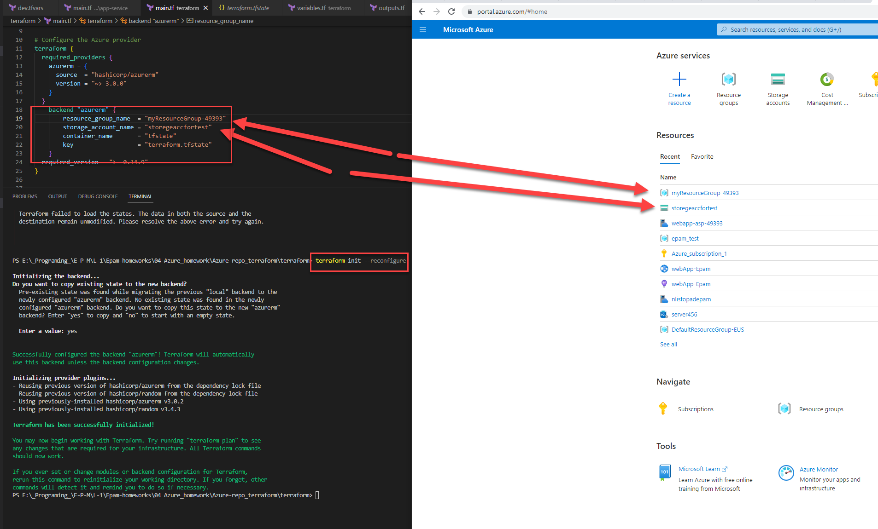

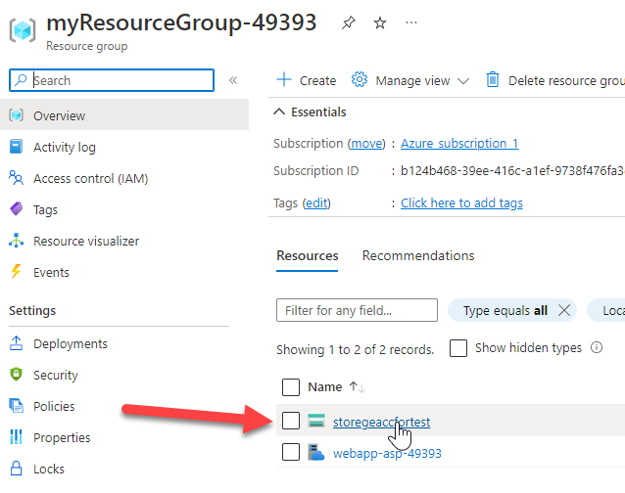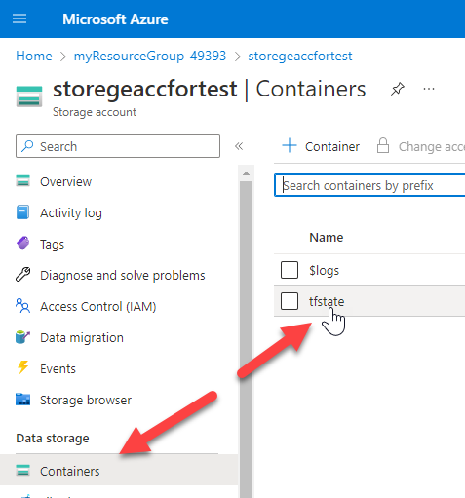

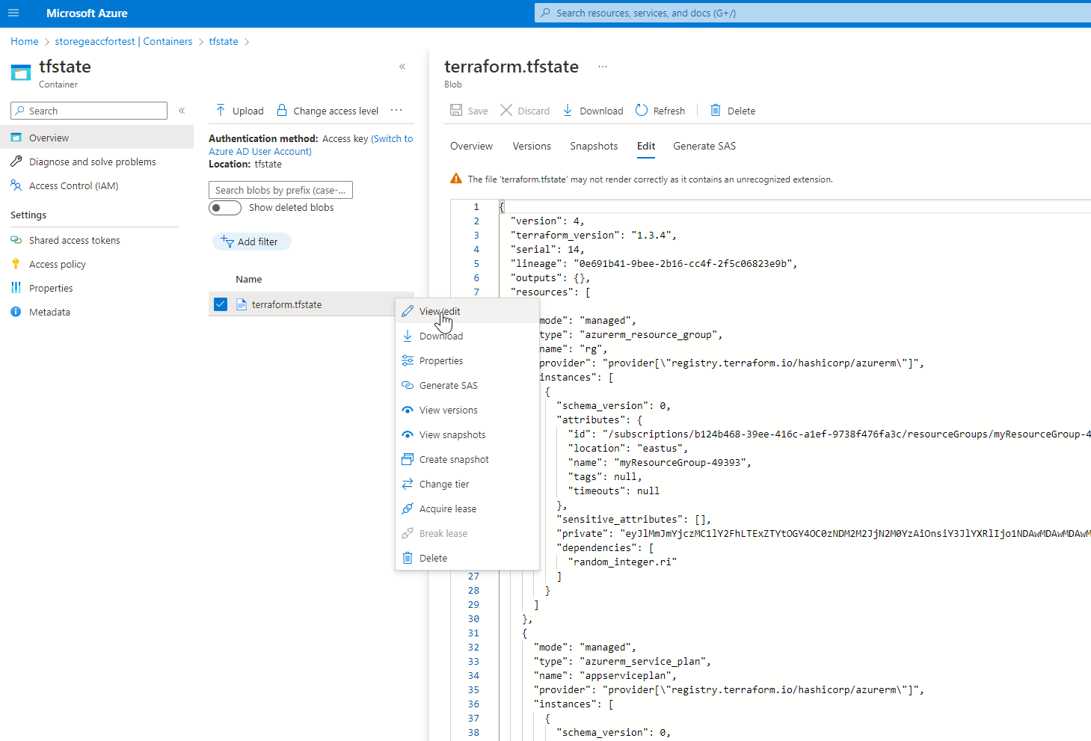

**6. Run az login or Connect-AzAccount to connect the azure subscription from your local**

**az login**

connect to your existing Azure account

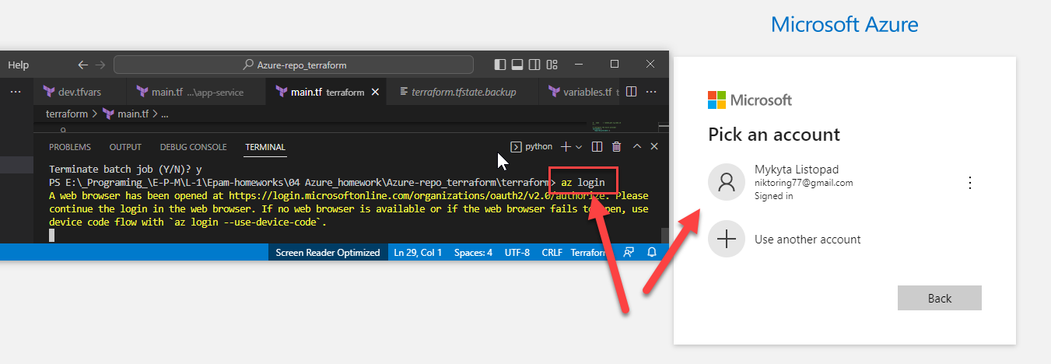

**7. Run terraform apply to deploy infrastructure**

**Important note: Use only freshest version of tf module like**<https://registry.terraform.io/providers/hashicorp/azurerm/latest/docs/resources/windows_web_app>

**terraform apply** create resource group in Azure cloud!

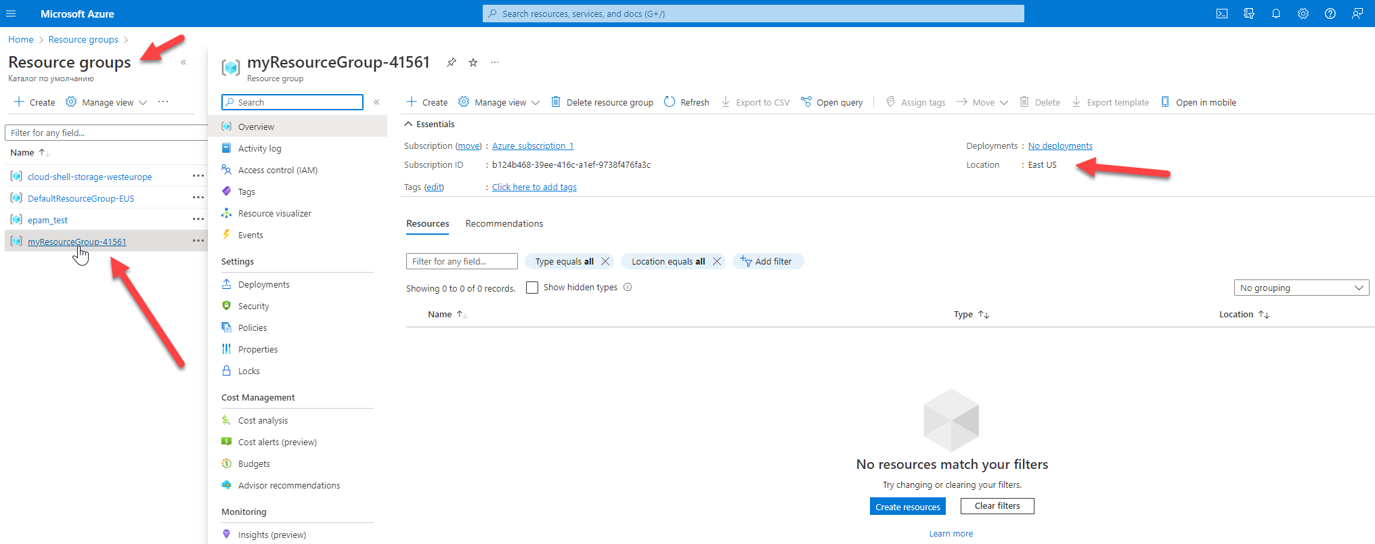

**terraform destroy** delete this group from cloud

**Important note: Don’t forget to destroy your application once completed**

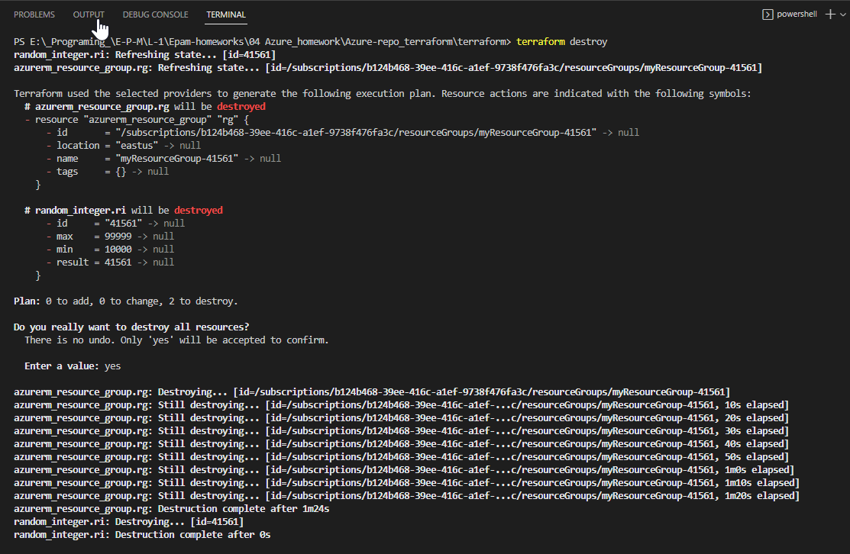

### **Create a terraform pipeline**

1. Create a yaml pipeline with the following steps: terraform install, terraform init, terraform plan/apply. Plan is an optional one

2. Inside yaml pipeline add trigger to main branch. The scenario – when main is updated, pipeline should run automatically -<https://learn.microsoft.com/en-us/azure/devops/pipelines/yaml-schema/trigger?view=azure-pipelines>

3. Added 3 steps – terraform install, terraform init, terraform plan/apply. Plan is an optional one. You may add it as 4th step

**MANUIL**

Create repo for terraform:

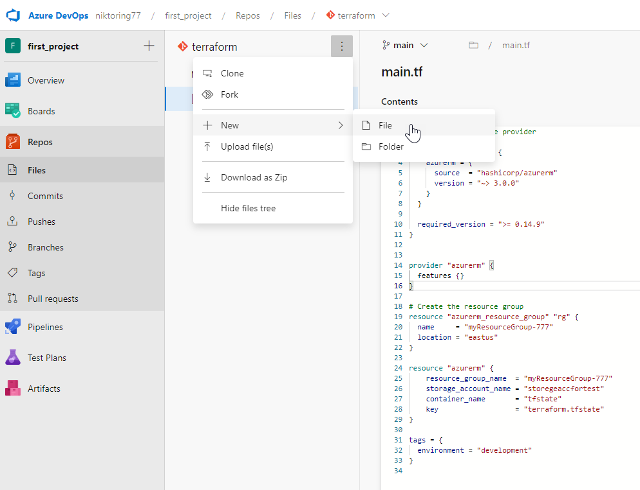

Create pipeline for artifact:

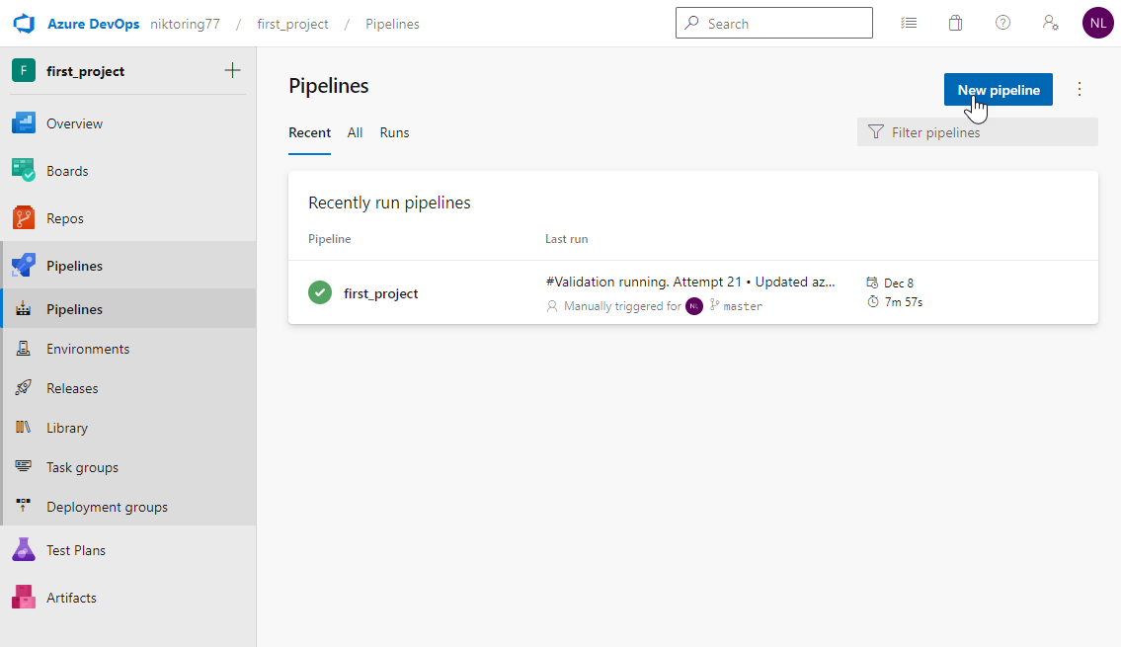

Another way to create an artifact for creating infrastructure and write state in existing (maybe some

default group) group and storage account

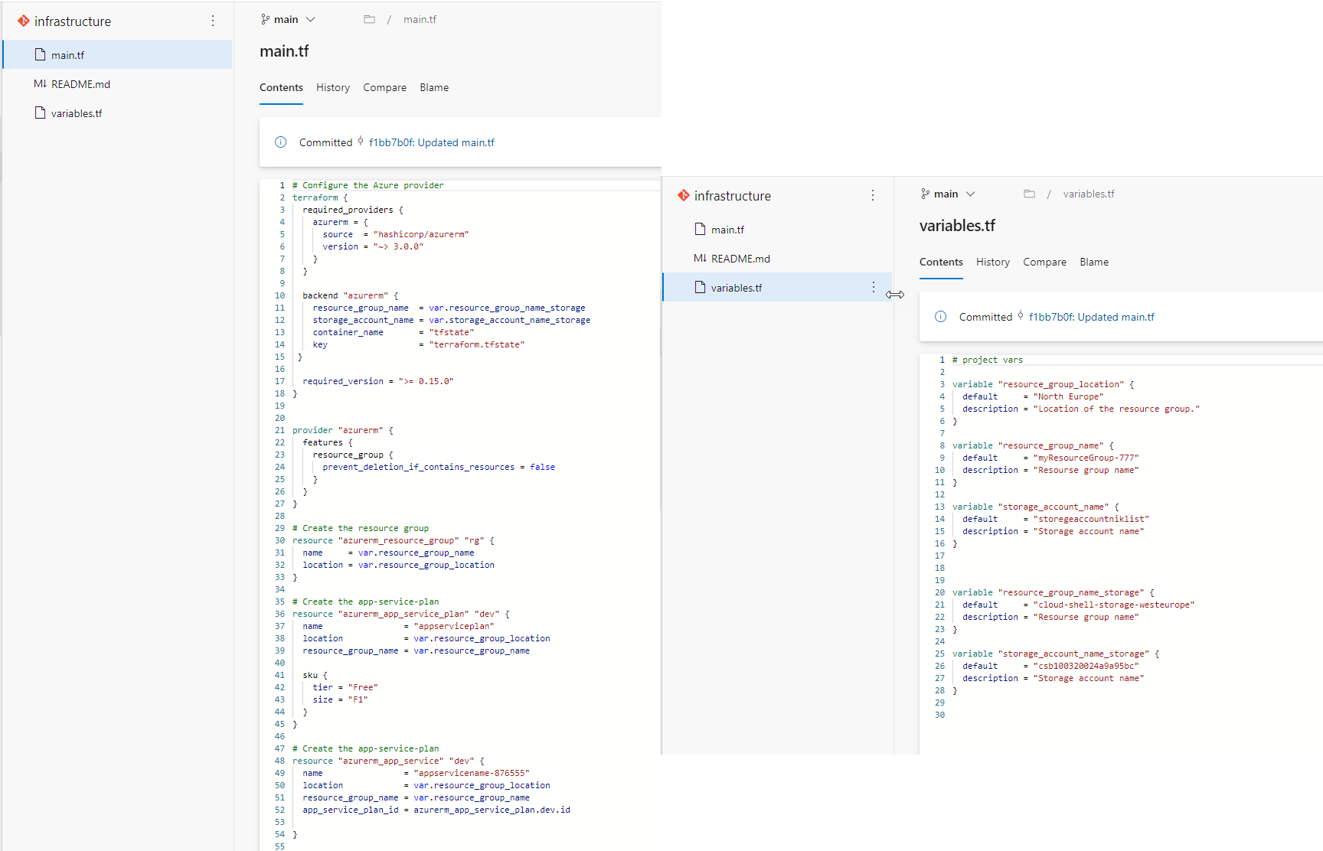

[Use the classic editor](https://dev.azure.com/niktoring77/first_project/_apps/hub/ms.vss-ciworkflow.build-ci-hub?_a=build-definition-getting-started&id=0) to create a pipeline without YAML.

## 

Empty job

## 

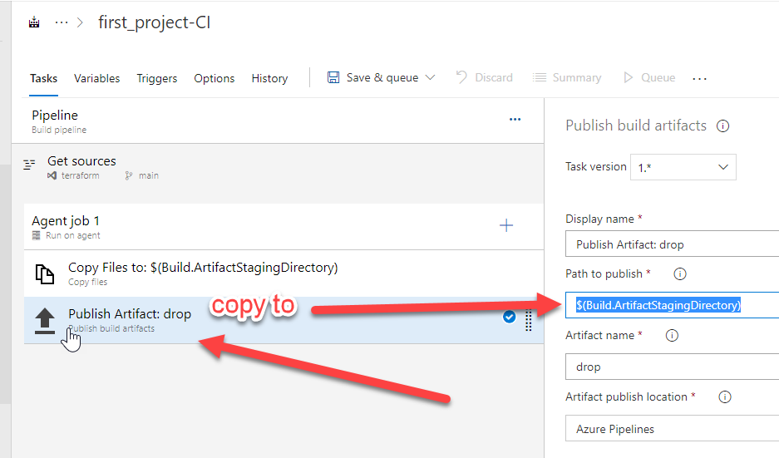

## 

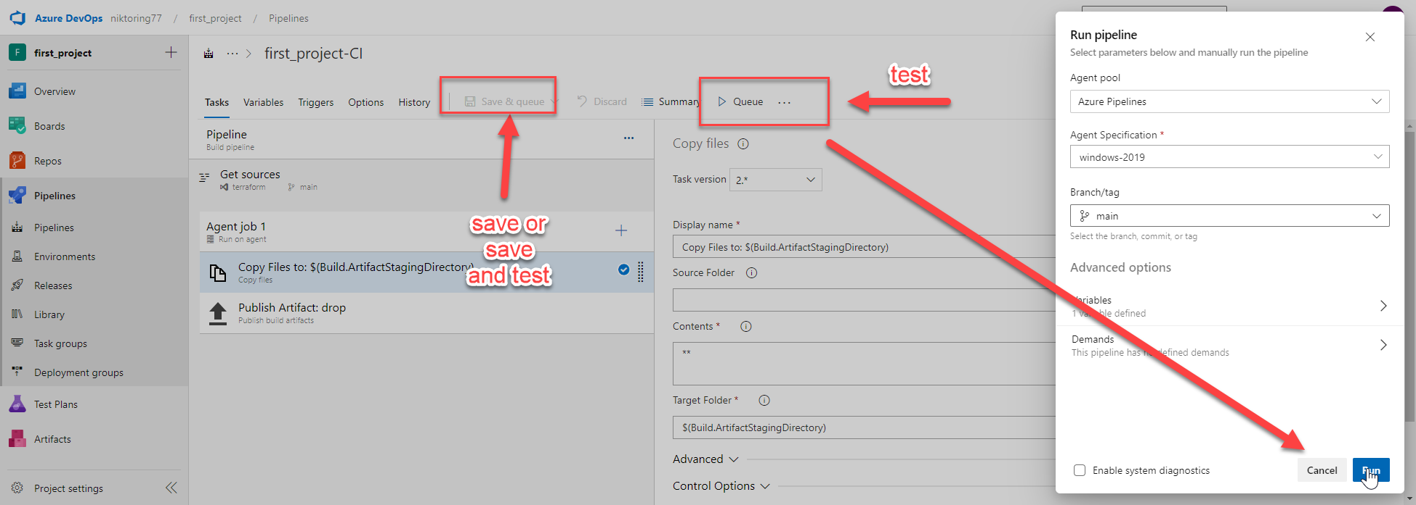

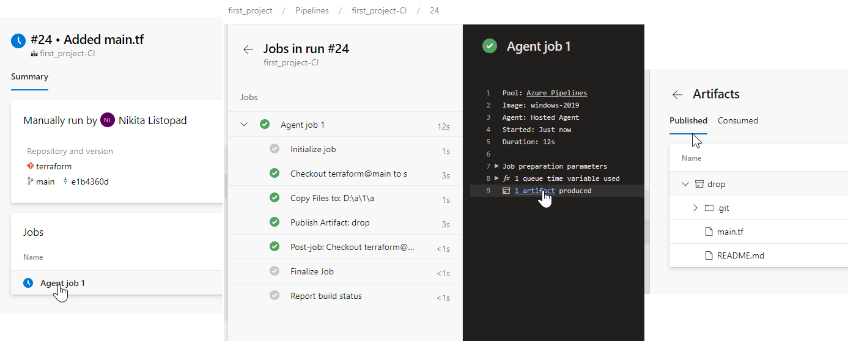

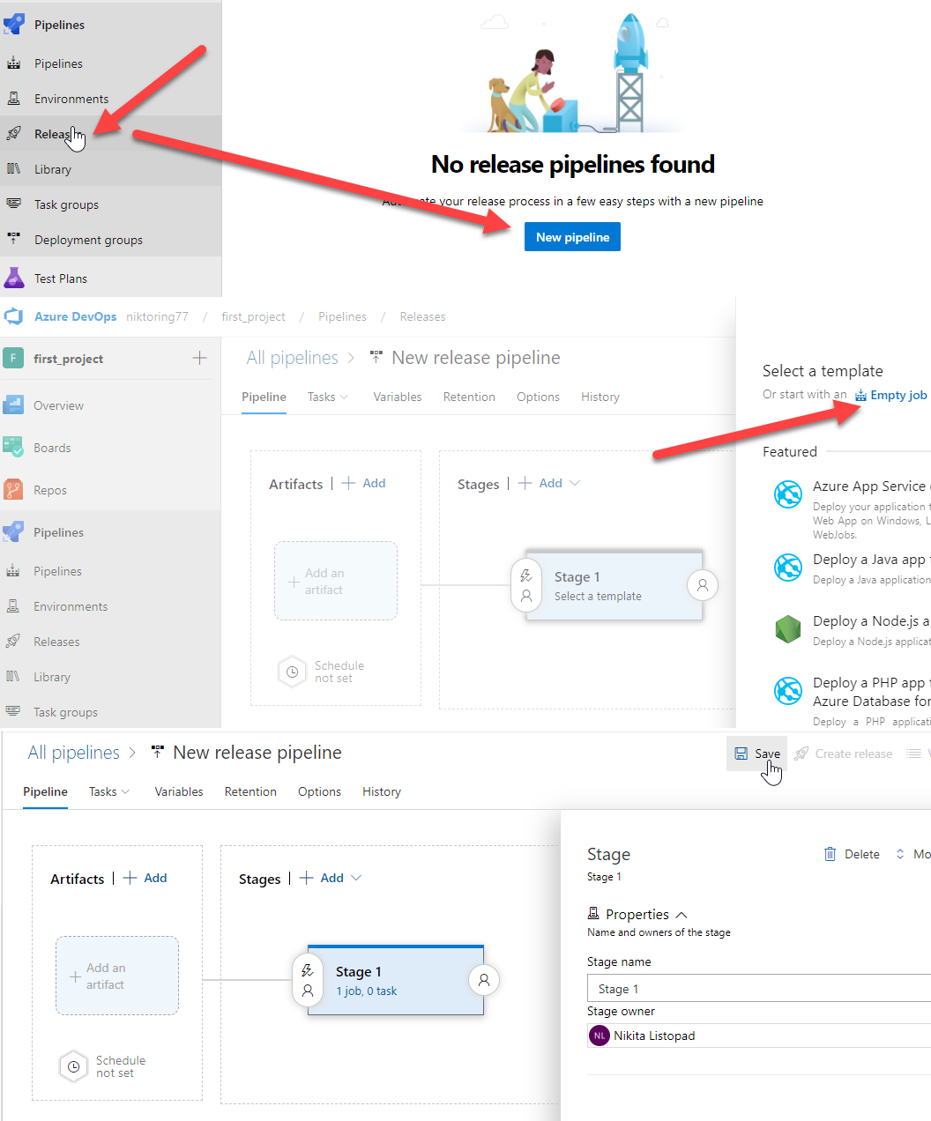

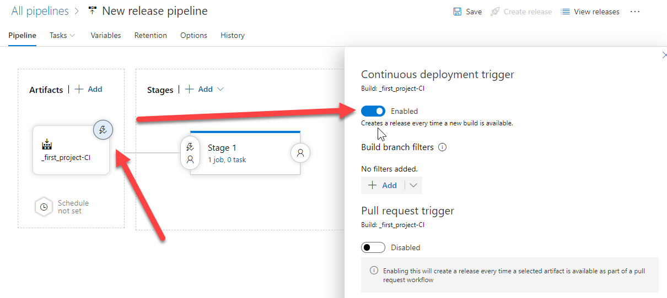

Enabling the trigger will create a new release every time a new build is available.

## 

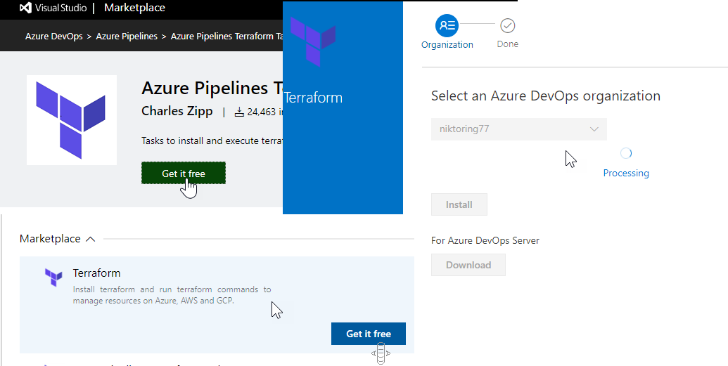

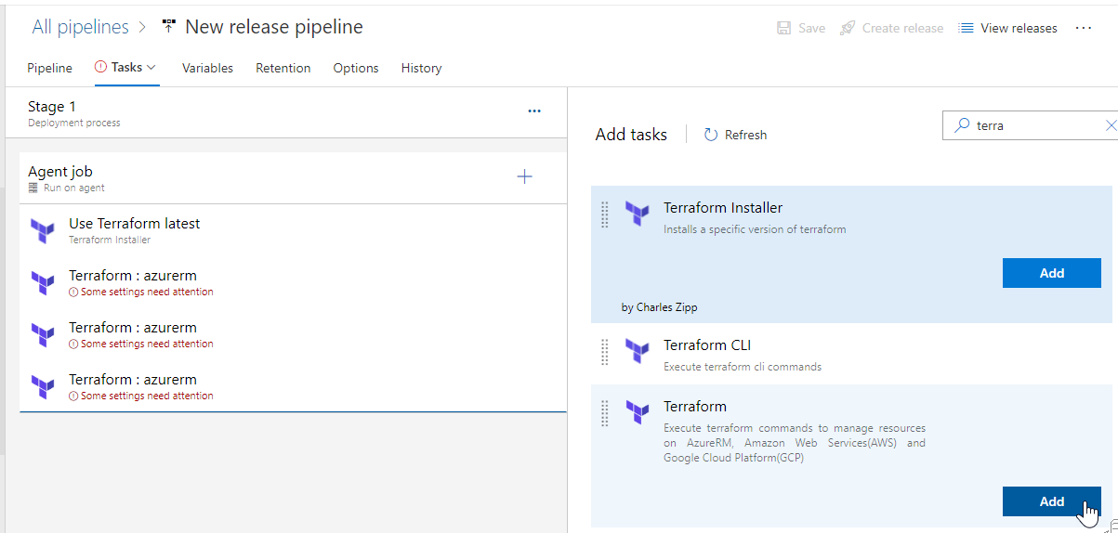

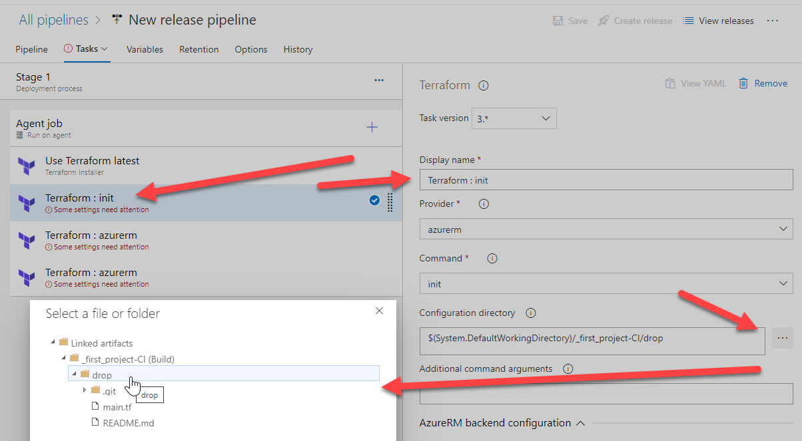

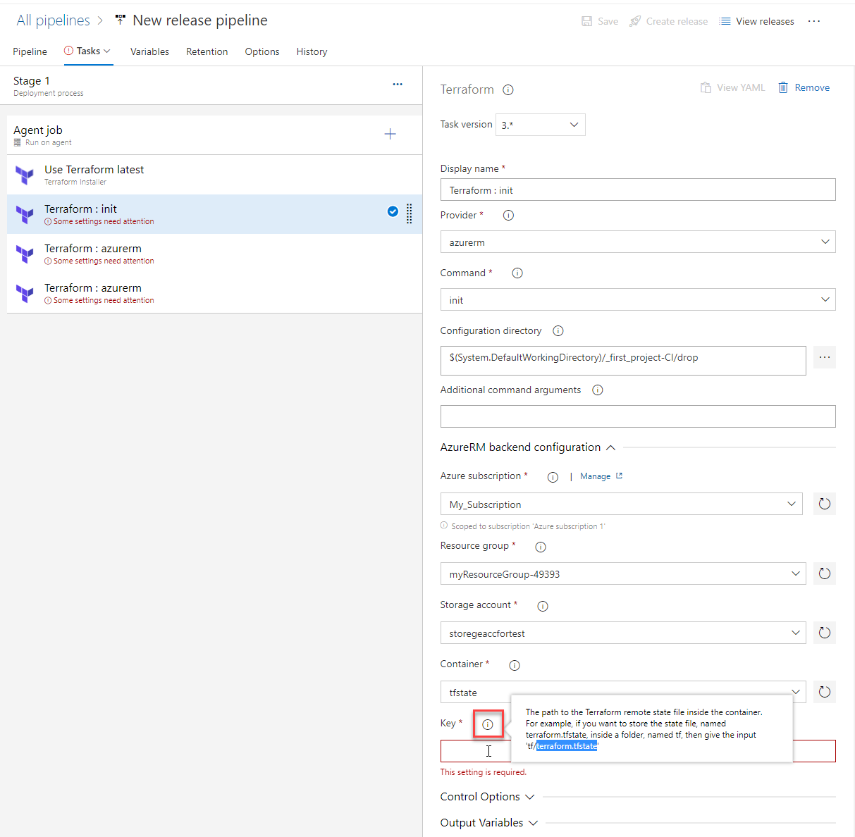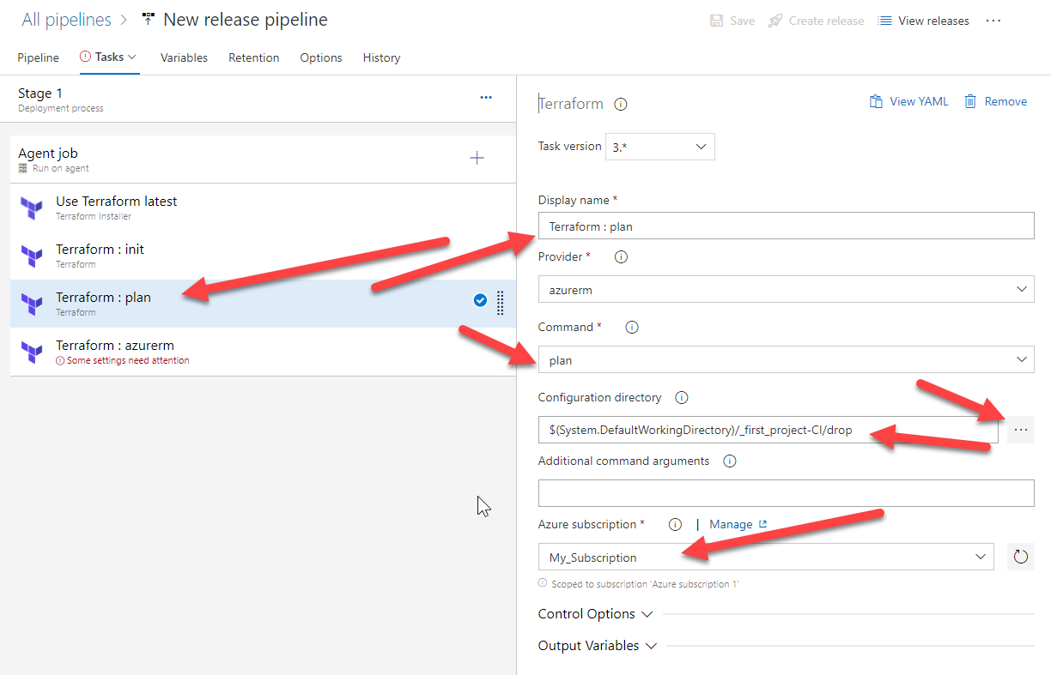

Option 1

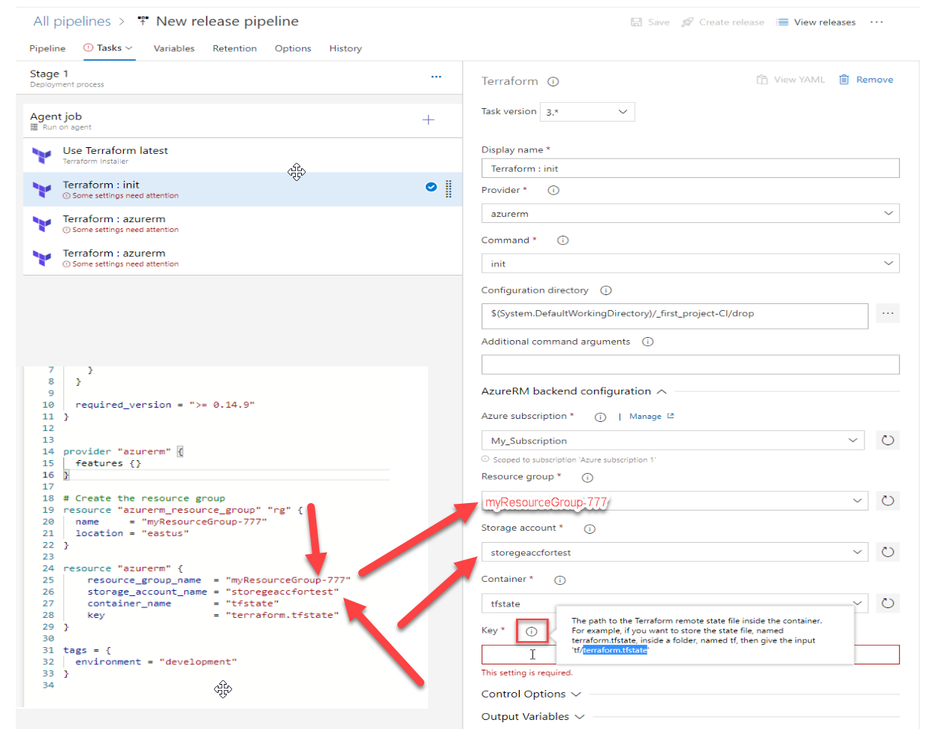

Option 2

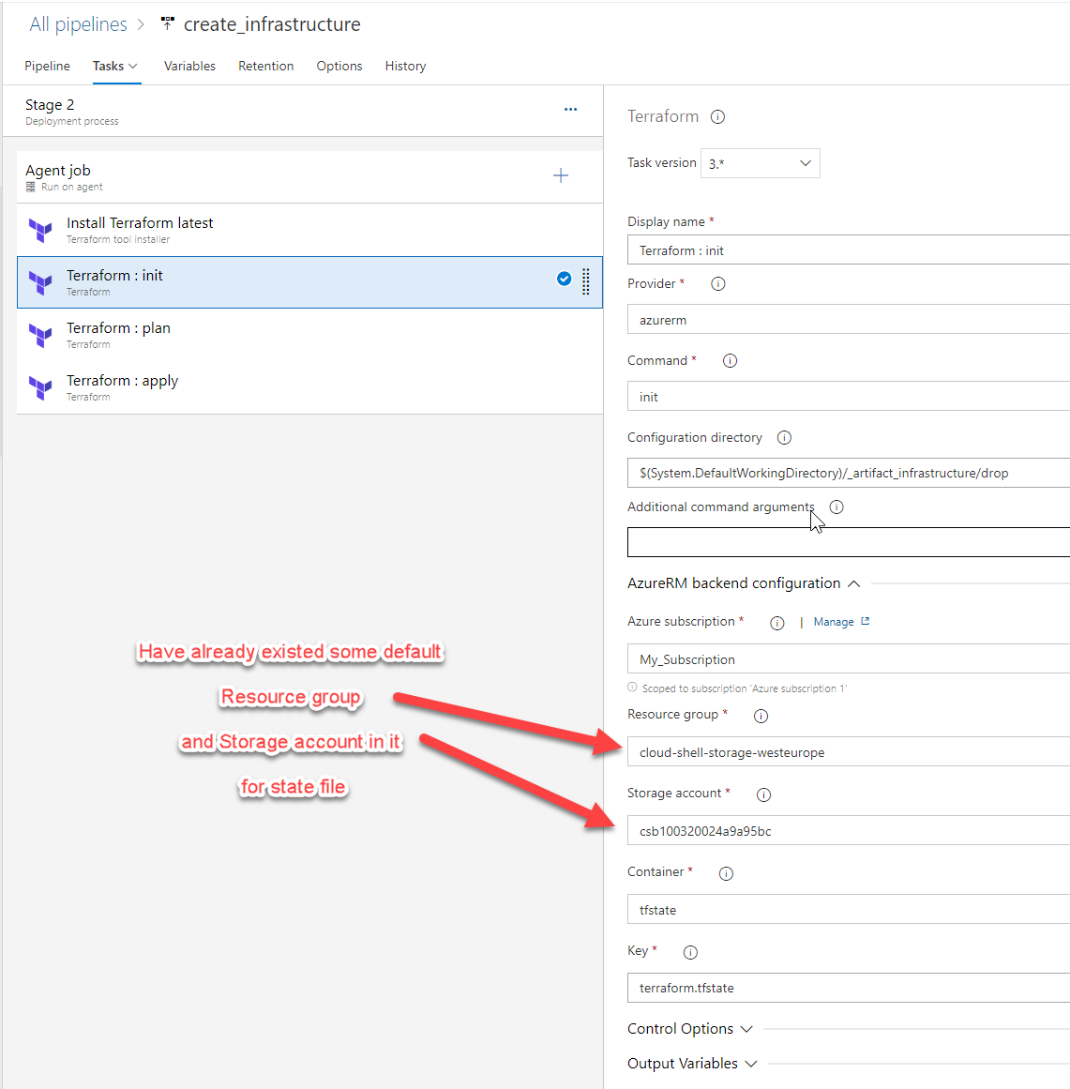

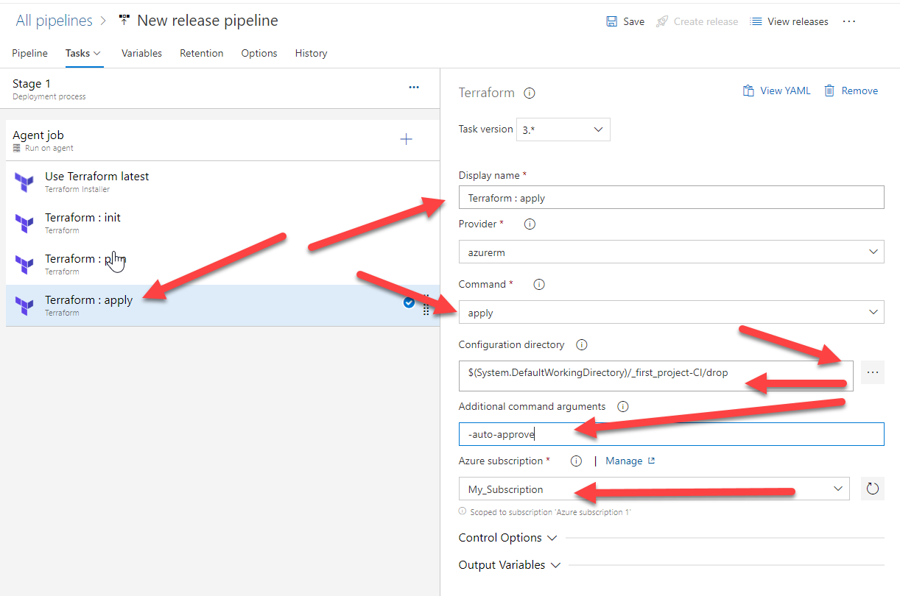

**SAVE**

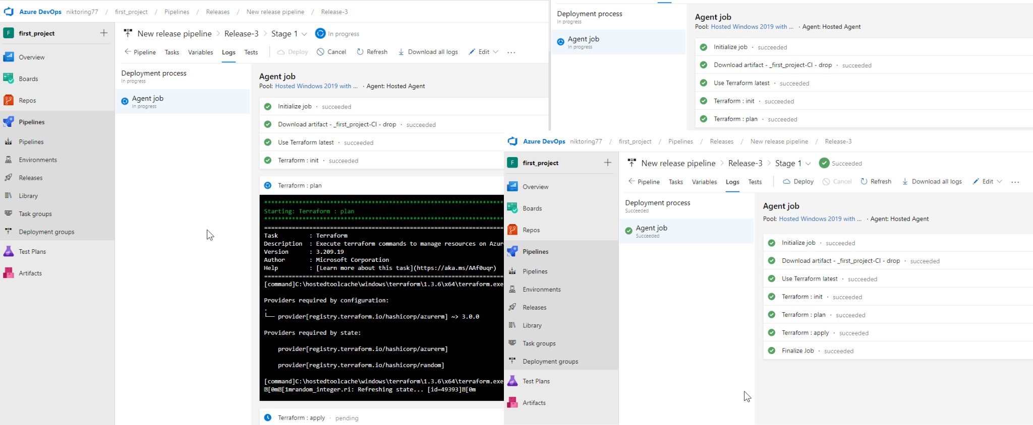

when I fix, add, rewrite some to file **main.tf** and create **ARTIFACT**

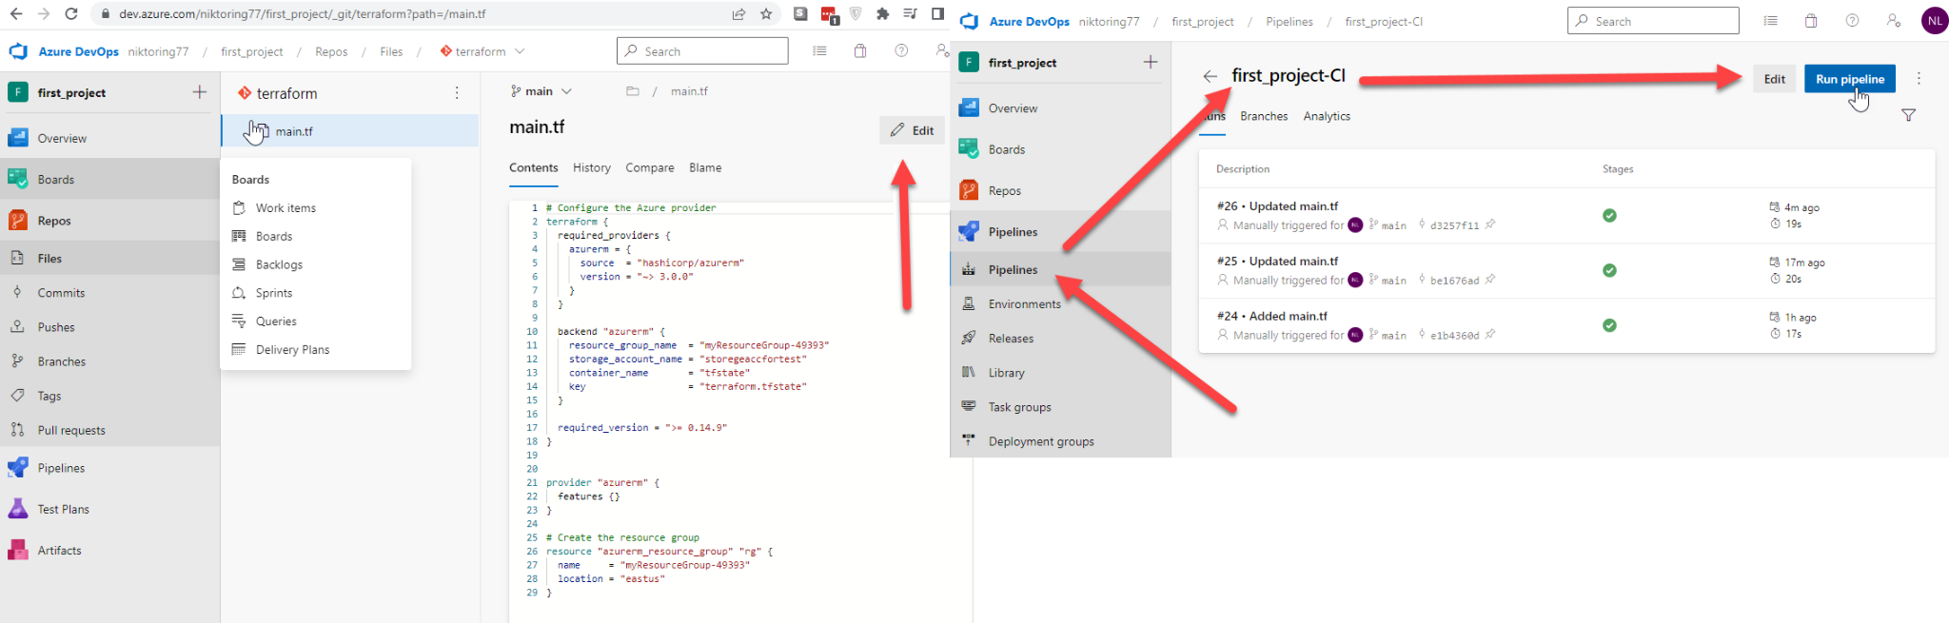

**RELEASE start automatically**

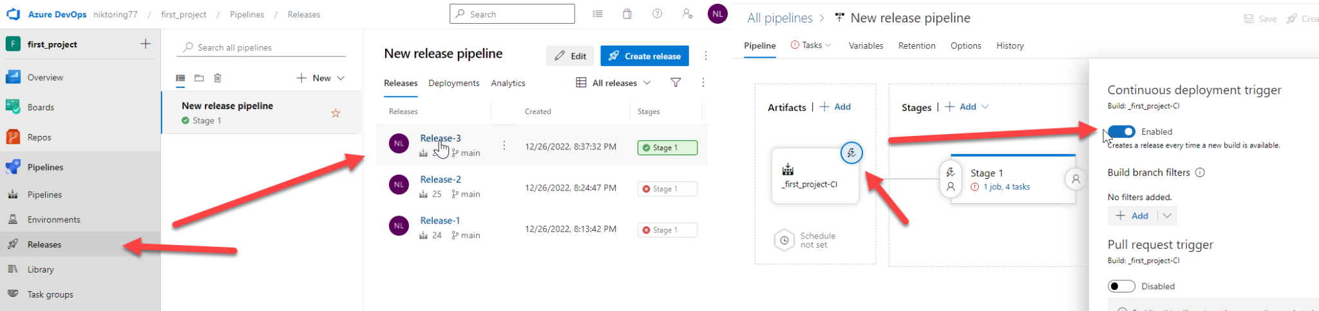

**PIPELINE with .yaml file**

Add the terraform extension from marketplace first of all

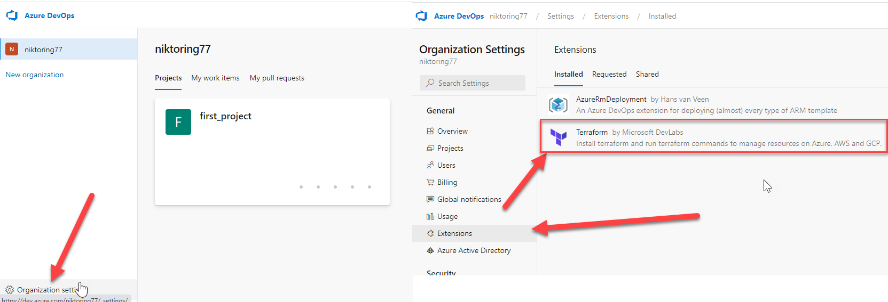

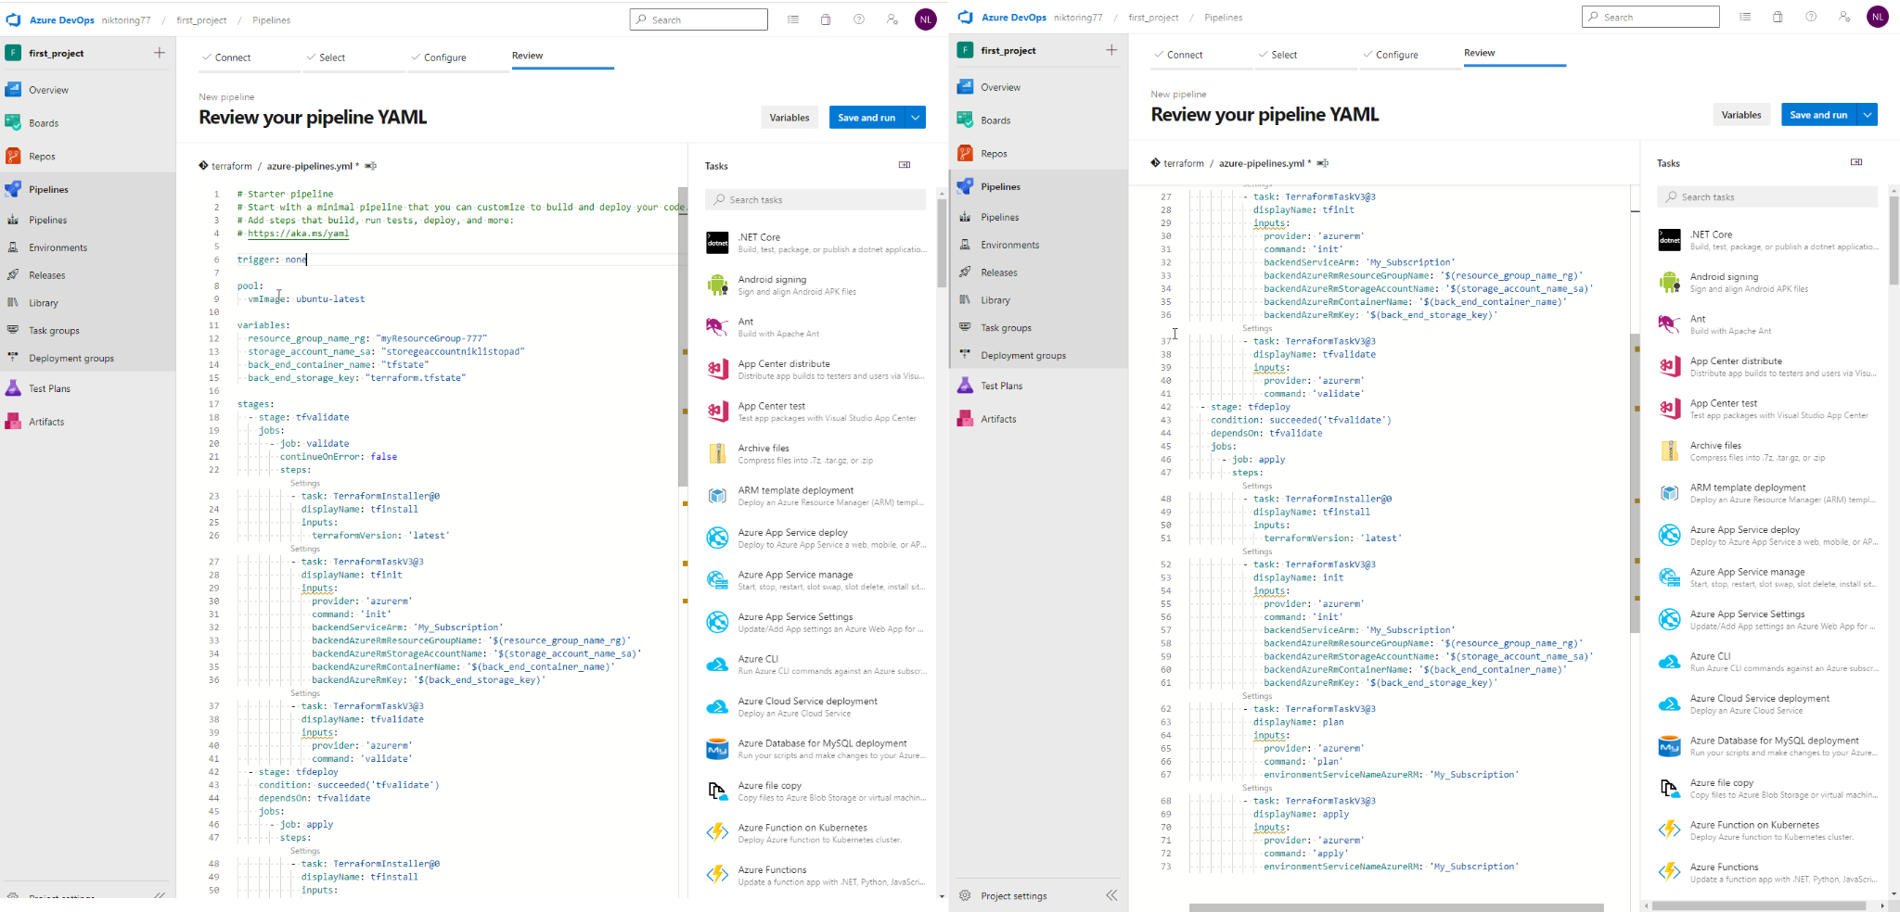

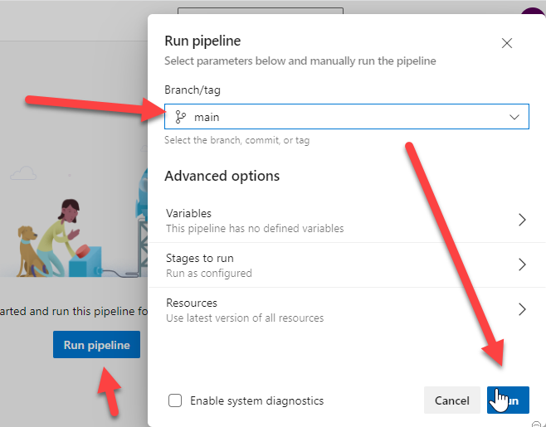

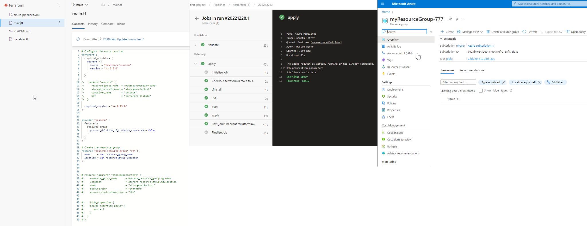

File view with a record of all were created entities

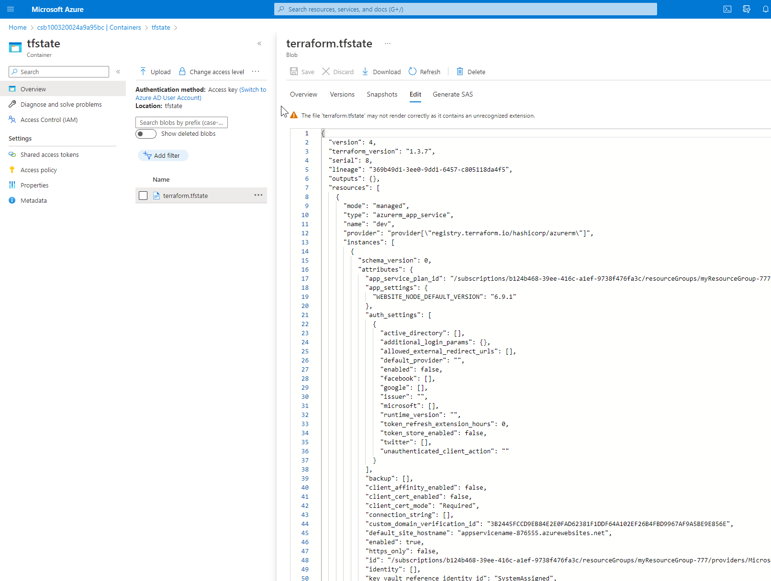

Destroy release of infrastructure

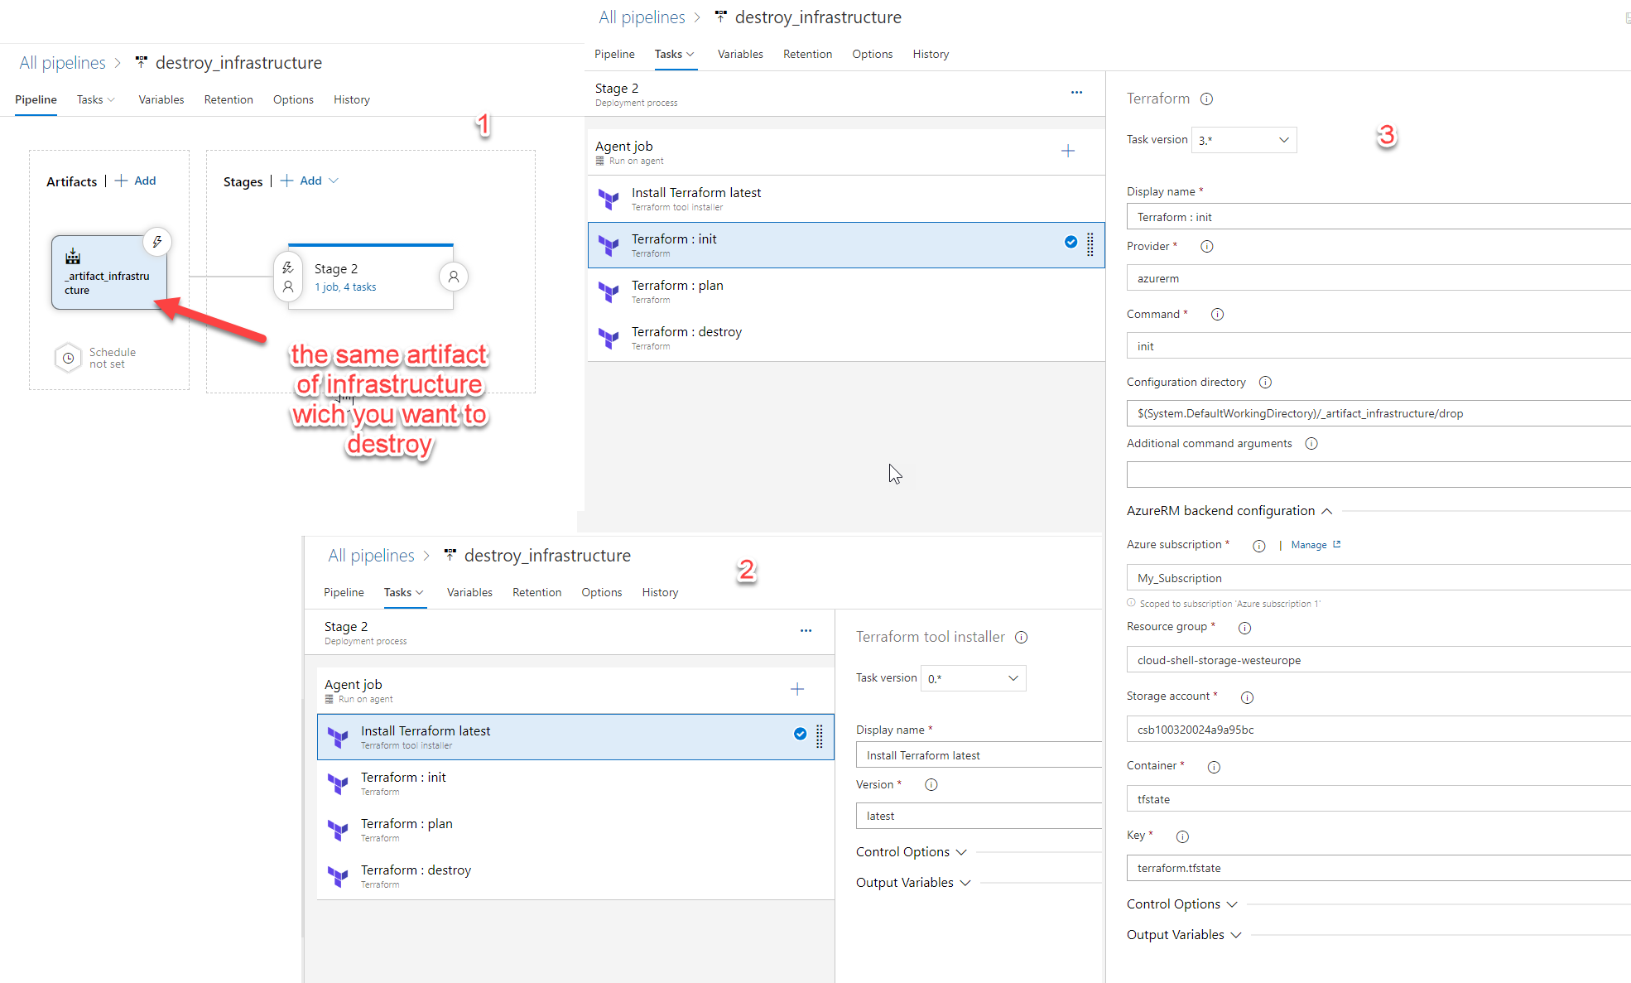

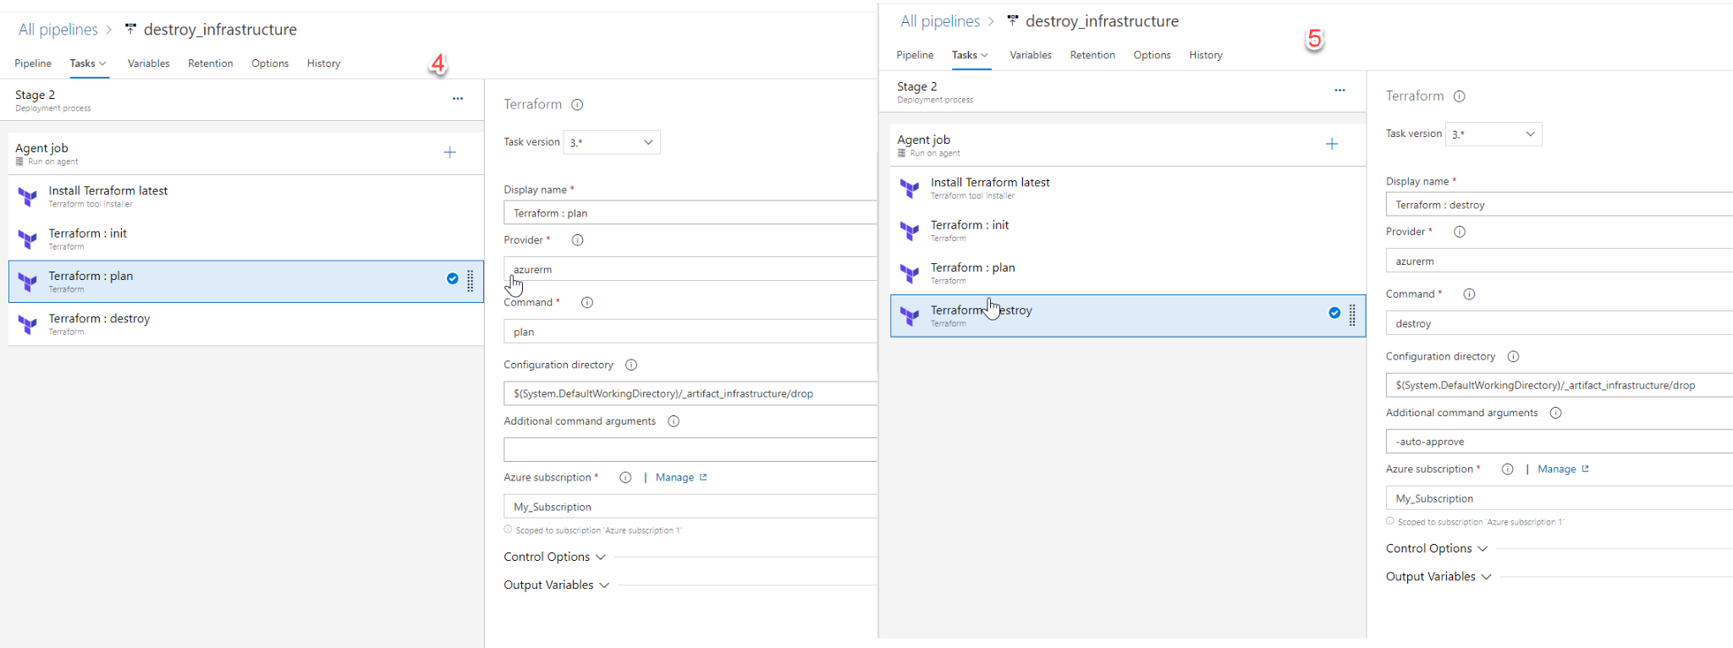

result in state file

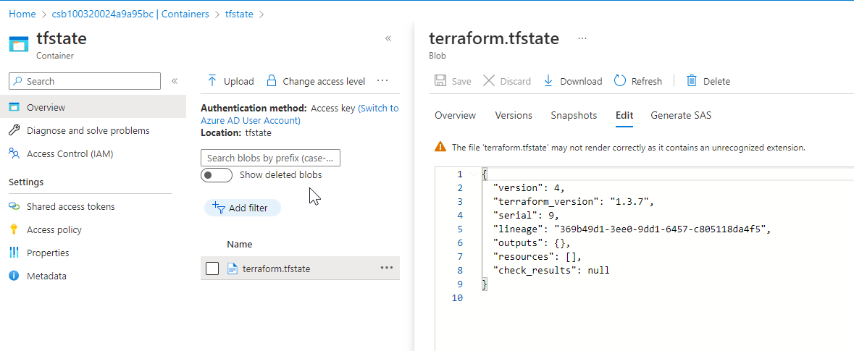

## **Part 3 – Create a deploy pipeline to app service**

1. Add yml pipeline to the application folder

2. Your pipeline structure should contain 2 stages. 1st – build, create zip archieve, and publish an artifact. 2nd – download an artifact and deploy it to azure app service

3. To deploy .zip to app service use azure app service deployment task

Service connection – manual way

<https://4bes.nl/2019/07/11/step-by-step-manually-create-an-azure-devops-service-connection-to-azure/>

Don’t forget to grant access on the subscription level for your enterprise application (service principal)

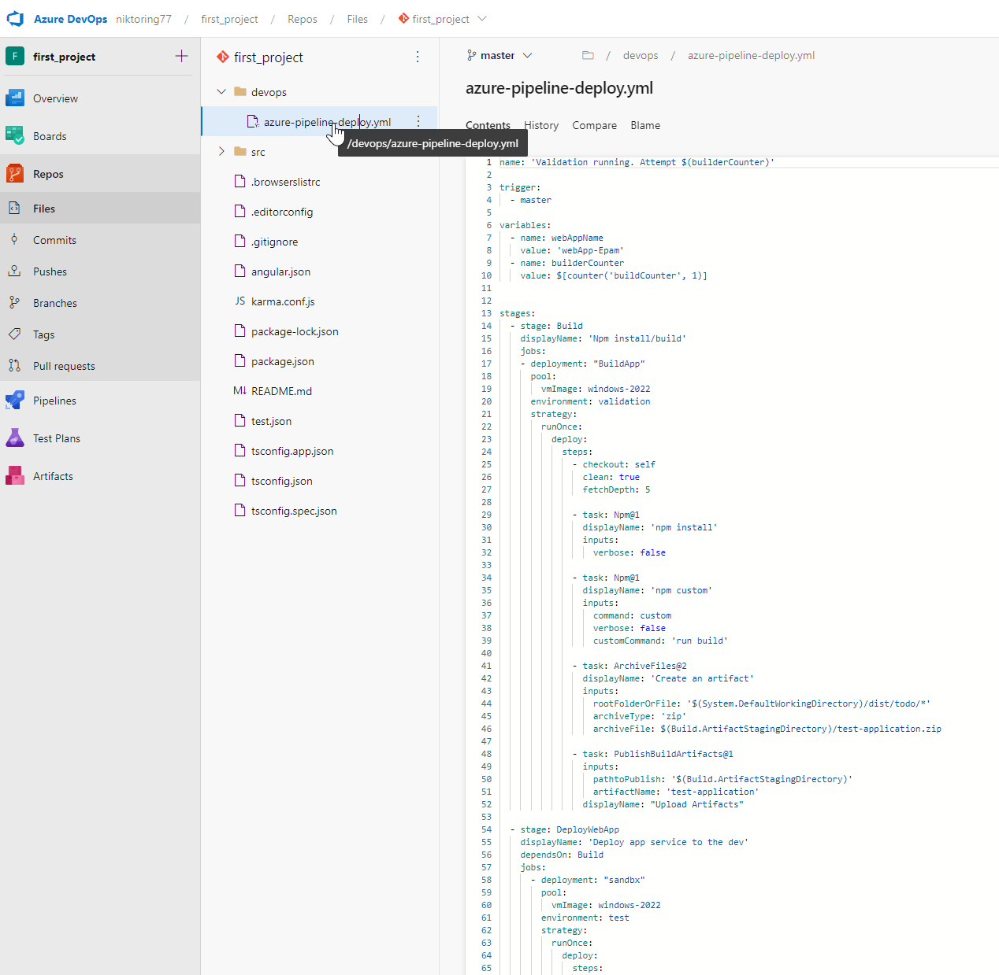

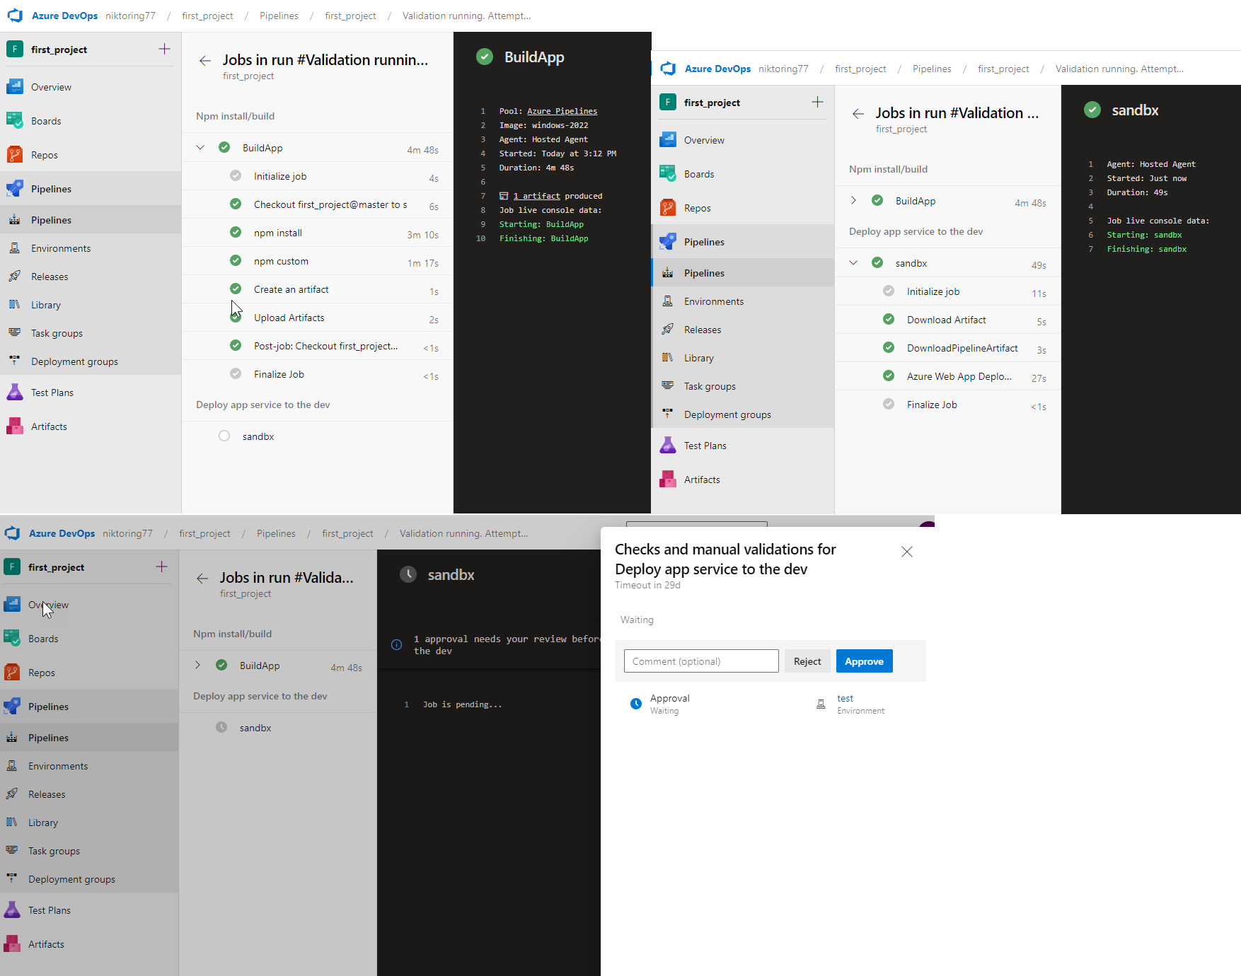

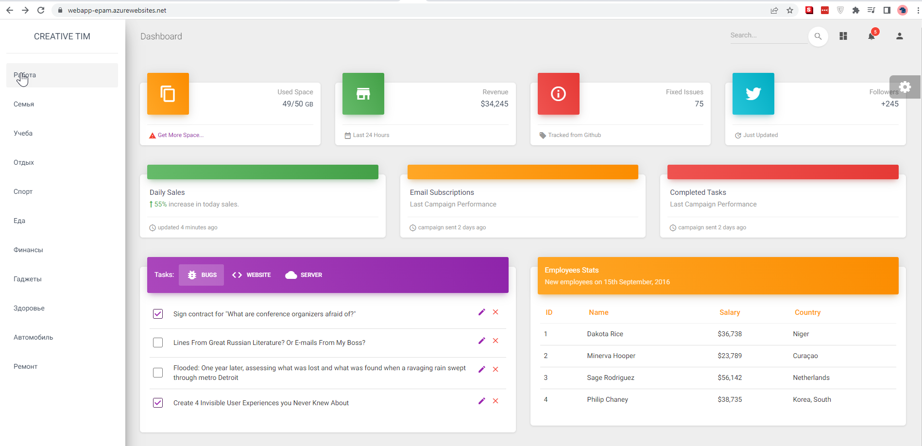

**Azure CLI deploy required Azure resources**

call az group create --location westeurop --name cloud-shell-storage-westeurope

call az storage account create --name csb100320024a9a95bc --resource-group cloud-shell-storage-westeurope --location westeurop --sku Standard_LRS

call az storage container create --name terraform --account-name csb100320024a9a95bc

call az storage account keys list -g cloud-shell-storage-westeurope -n csb100320024a9a95bc

example 2

call az group create --location westeurop --name $(terraformstoragerg)

call az storage account create --name $(terraformstorageaccount) --resource-group $(terraformstoragerg) --location westeurop --sku Standard_LRS

call az storage container create --name terraform --account-name $(terraformstorageaccount)

call az storage account keys list -g $(terraformstoragerg) -n $(terraformstorageaccount)

**Azure PowerShell script: InlineScript**

# You can write your azure powershell scripts inline here.

# You can also pass predefined and custom variables to this script using arguments

$key=(Get-AzureRmStorageAccountKey -ResourceGroupName $(cloud-shell-storage-westeurope) -AccountName $(csb100320024a9a95bc)).Value[0]

Write-Host "##vso[task.setvariable variable=storagekey]$key"